Curved Path

Definition
# Source: AI Source: Provided by: [Data Path: Persons Table -> ID Column: 1, Name_En Column: Motasem Essam] -> From: [ChatGPT] on [7/25/2026]
A Curved Path is a geometric path in which a moving point follows a trajectory that is not a single straight line. The direction of motion changes continuously or at specific portions of the path, and the path generally has nonzero curvature.
A curved path can be represented by a curve such as a circle, parabola, ellipse, hyperbola, or another smooth or piecewise-defined curve.
$$\boxed{\text{Curved Path}=\text{Path that follows a non-straight curve}}$$
For a parametrically defined path,
$$r\left(t\right)=\left(x , \left(t\right)y\left(t\right)\right)$$
the path is curved when its direction changes as the parameter $t$changes.
Simple Definition
A Curved Path is a path that bends instead of following one straight line.

Main Classification
# Source: AI Source: Provided by: [Data Path: Persons Table -> ID Column: 1, Name_En Column: Motasem Essam] -> From: [ChatGPT] on [7/25/2026]
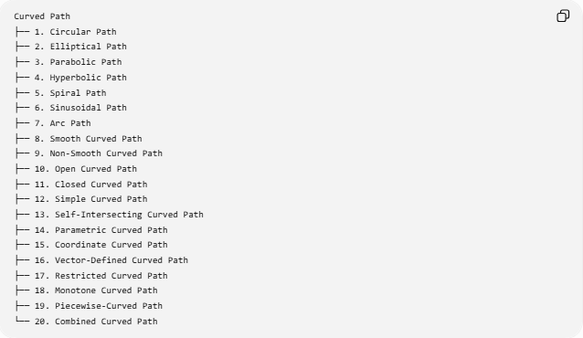
Curved Path
├── 1. Circular Path
├── 2. Elliptical Path
├── 3. Parabolic Path
├── 4. Hyperbolic Path
├── 5. Spiral Path
├── 6. Sinusoidal Path
├── 7. Arc Path
├── 8. Smooth Curved Path
├── 9. Non-Smooth Curved Path
├── 10. Open Curved Path
├── 11. Closed Curved Path
├── 12. Simple Curved Path
├── 13. Self-Intersecting Curved Path
├── 14. Parametric Curved Path
├── 15. Coordinate Curved Path
├── 16. Vector-Defined Curved Path
├── 17. Restricted Curved Path
├── 18. Monotone Curved Path
├── 19. Piecewise-Curved Path
└── 20. Combined Curved Path

Circular Path
# Source: AI Source: Provided by: [Data Path: Persons Table -> ID Column: 1, Name_En Column: Motasem Essam] -> From: [ChatGPT] on [7/25/2026]
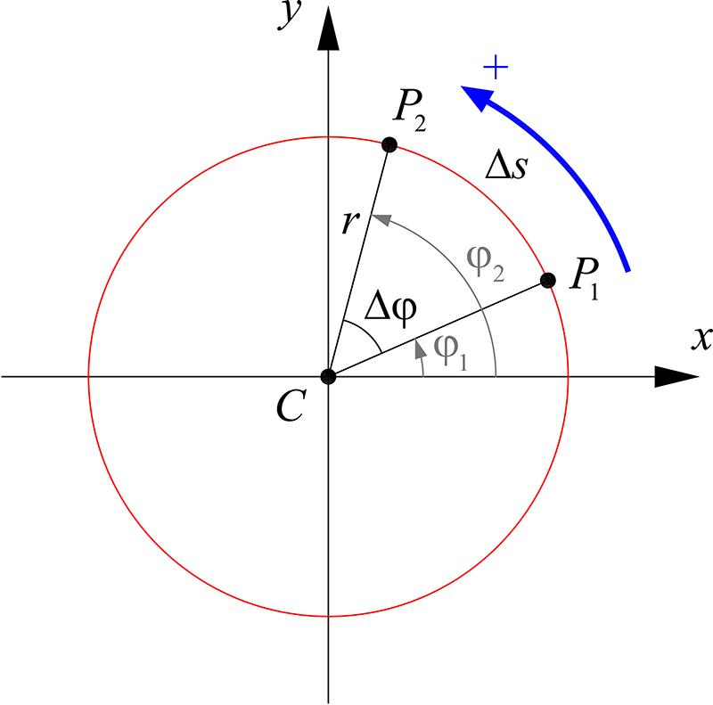
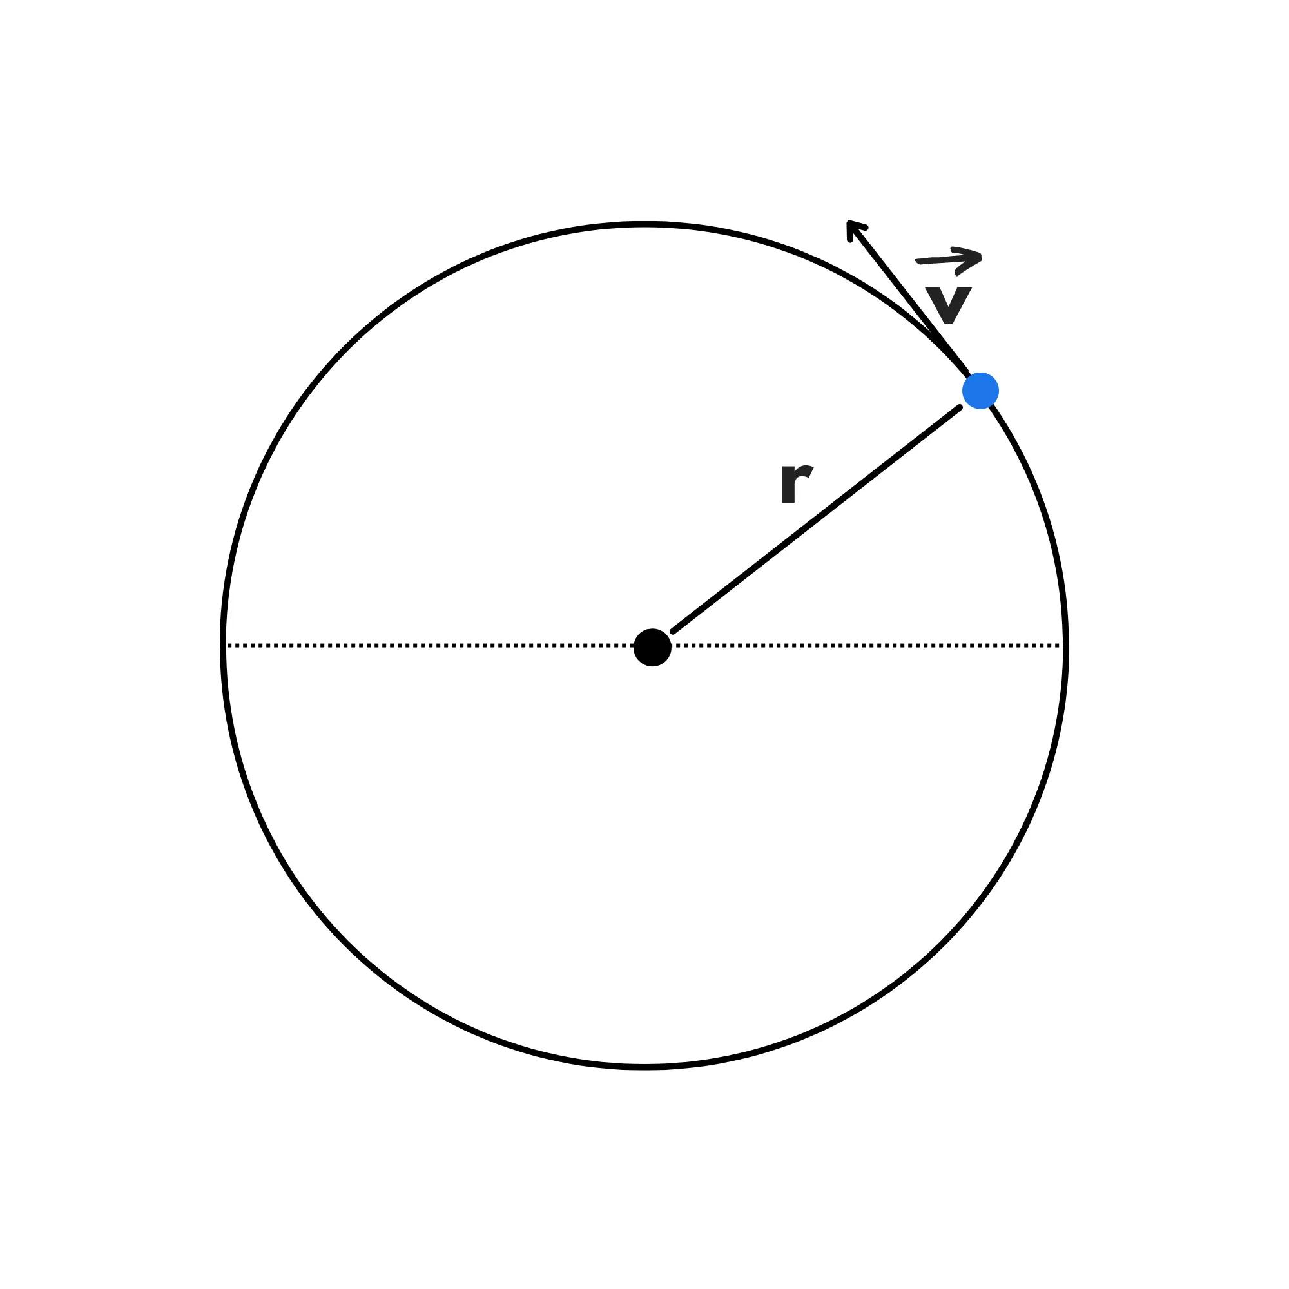
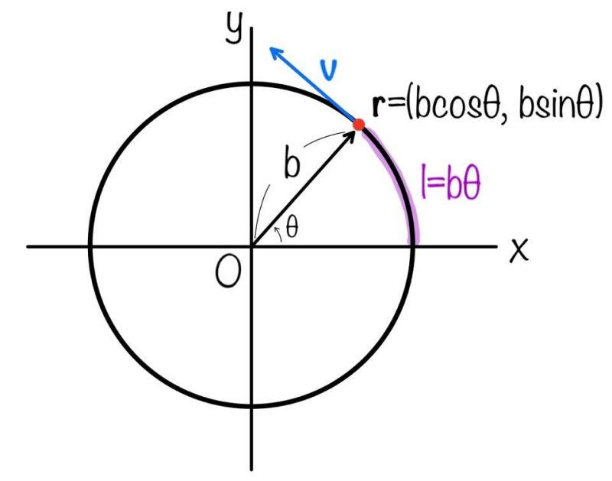
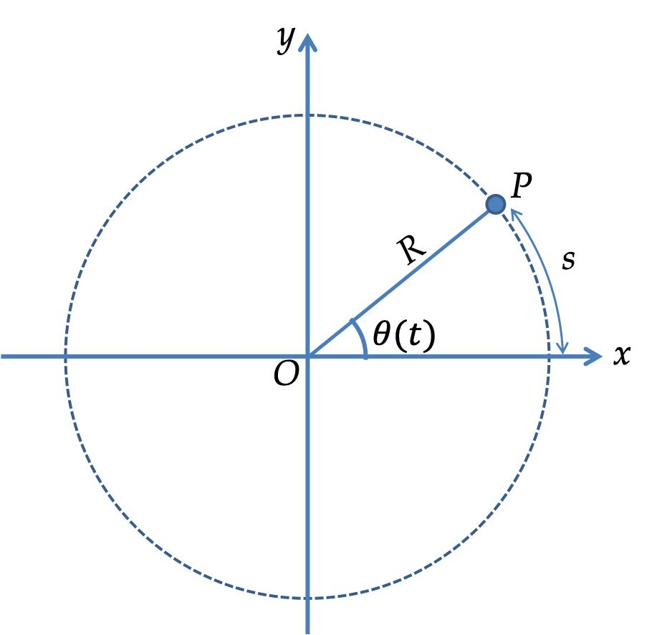
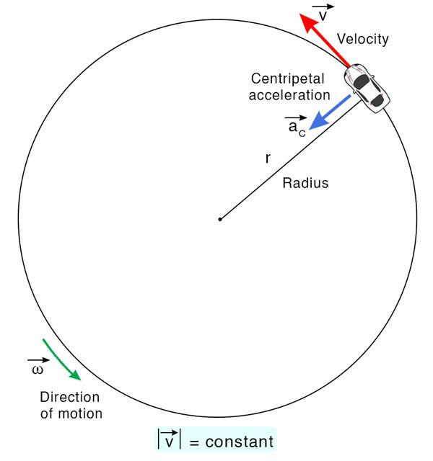
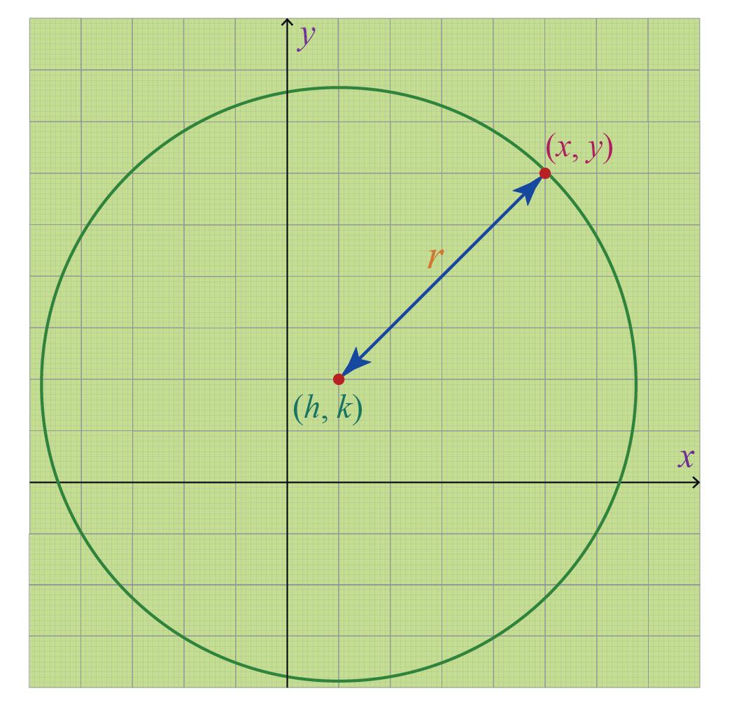
A Circular Path is a curved path in which every point of the path remains at a constant distance from a fixed center.
$$\boxed{OP=r}$$
where:
- $O$= center
- $P$= moving point
- $r$= constant radius
Example
A point moving around a circle of radius $5$cm follows a circular path.
$$OP=5$$
Important Property
The curvature is constant:
$$\boxed{κ=\frac{1}{r}}$$

2. Elliptical Path
# Source: AI Source: Provided by: [Data Path: Persons Table -> ID Column: 1, Name_En Column: Motasem Essam] -> From: [ChatGPT] on [7/25/2026]
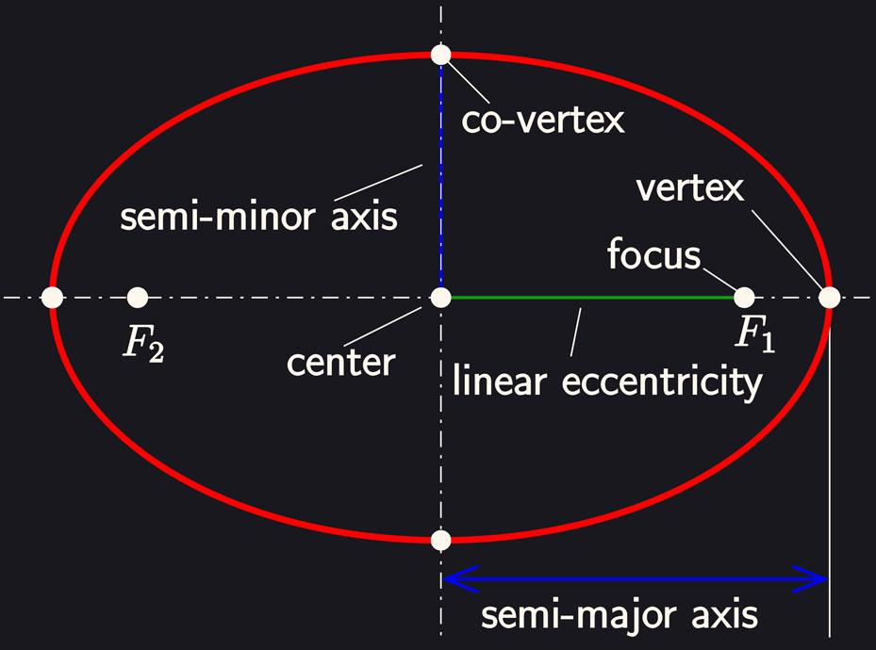
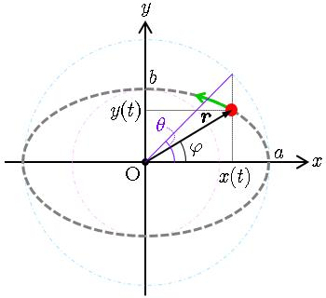
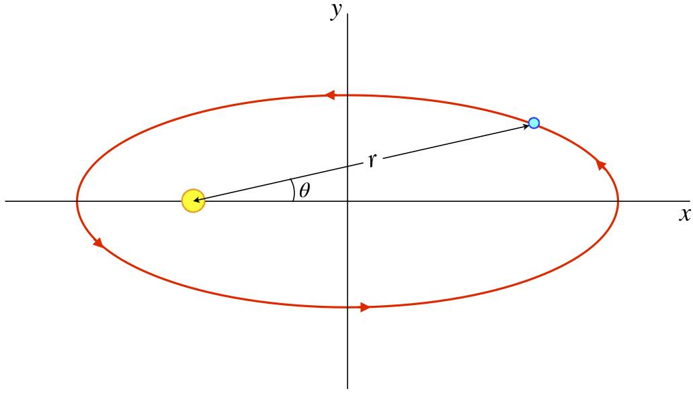
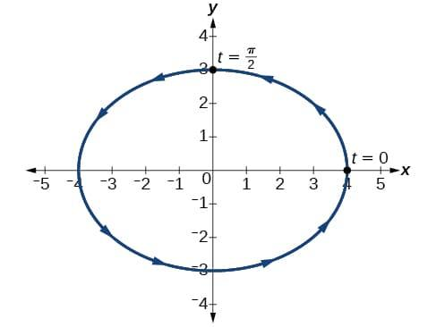
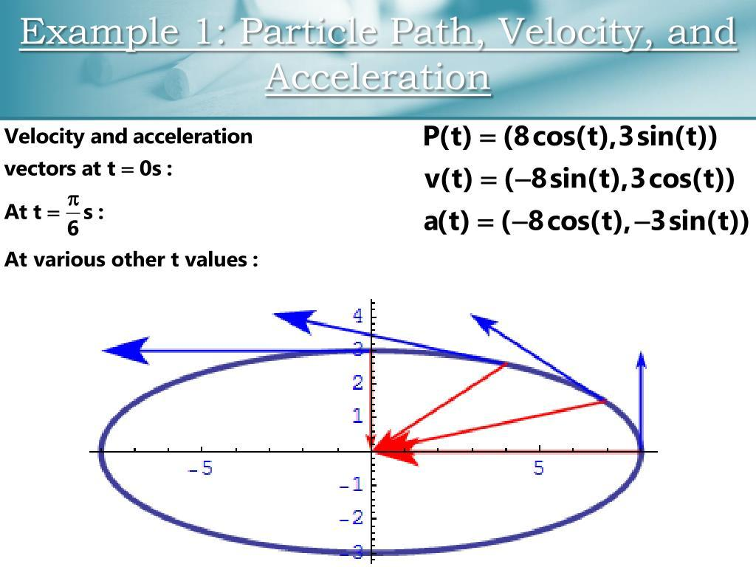
An Elliptical Path follows an ellipse.
An ellipse is defined by two fixed foci $F_{1},F_{2}$, such that
$$\boxed{PF_{1}+PF_{2}=2a}$$
for every point $P$on the ellipse.
Standard Equation
$$\frac{x^{2}}{a^{2}}+\frac{y^{2}}{b^{2}}=1$$
Example
A satellite following an idealized elliptical orbit around a body follows an elliptical path.
Important Property
Unlike a circle, the distance from the center is not constant.

3. Parabolic Path
# Source: AI Source: Provided by: [Data Path: Persons Table -> ID Column: 1, Name_En Column: Motasem Essam] -> From: [ChatGPT] on [7/25/2026]
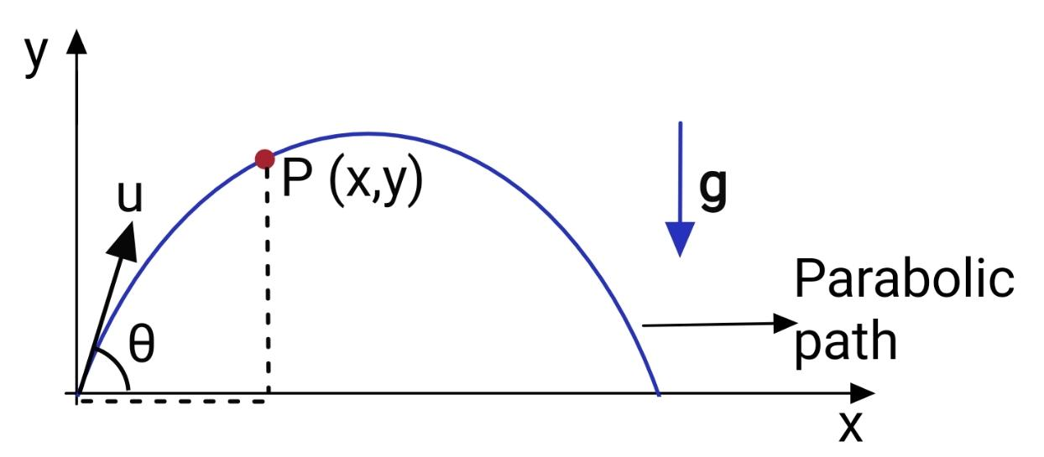
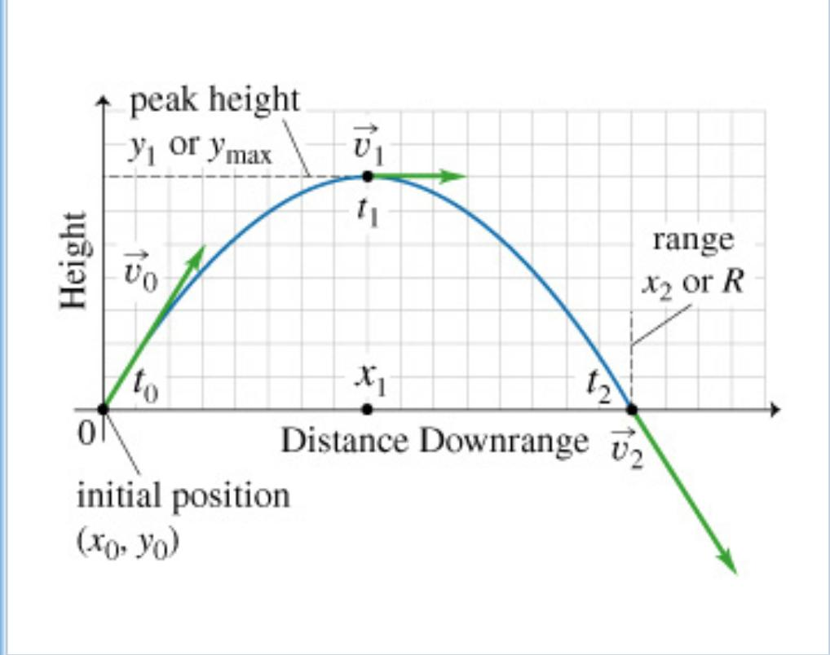
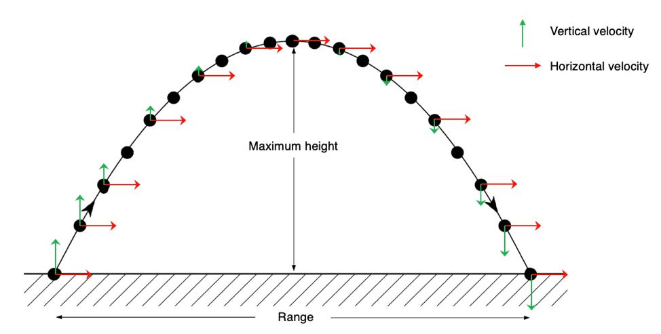
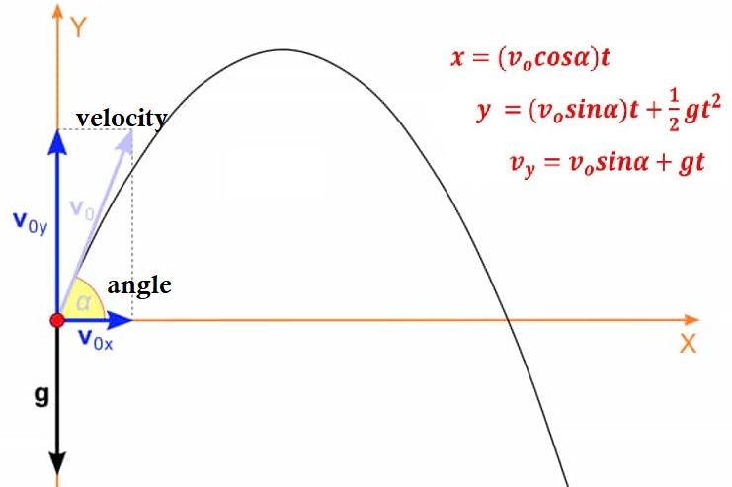
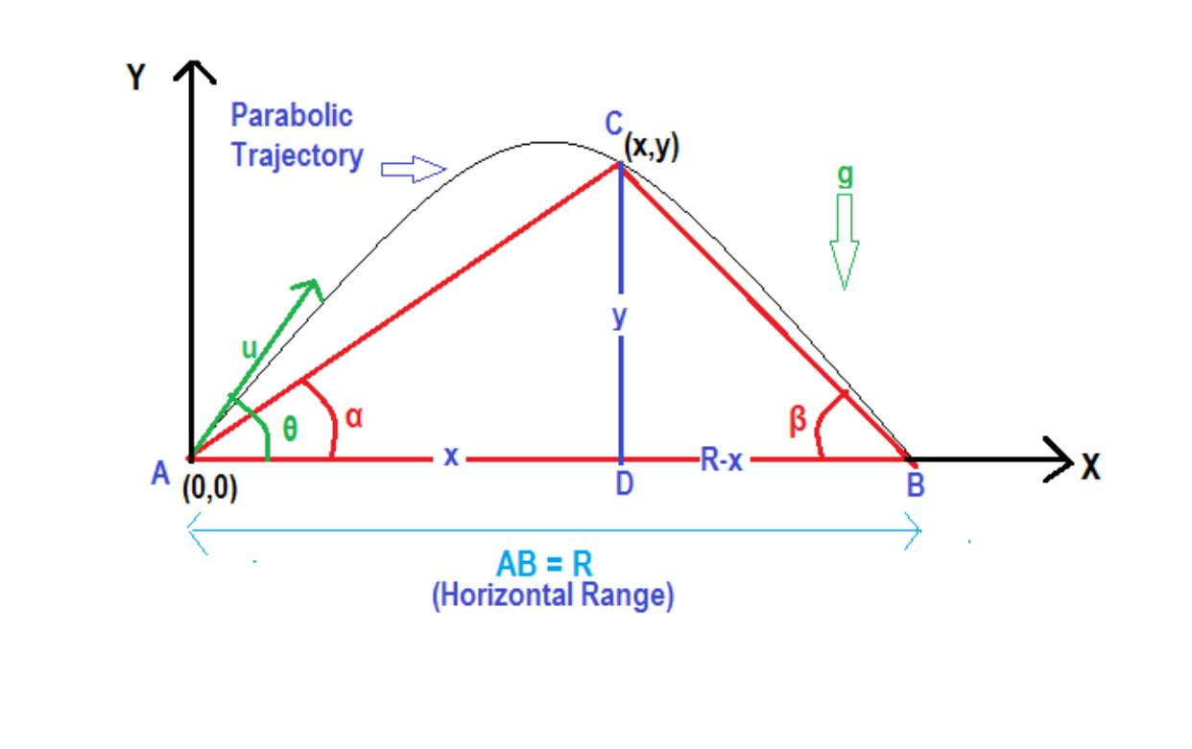
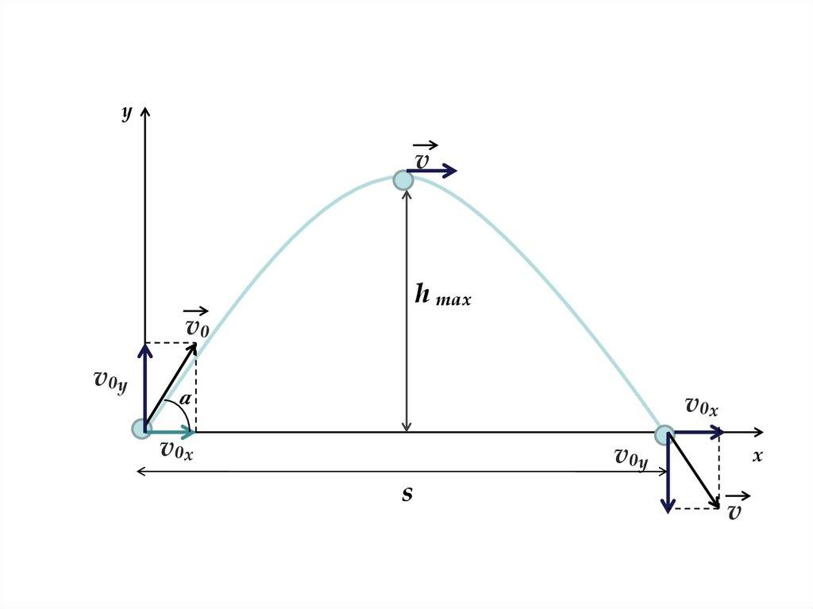
A Parabolic Path follows a parabola.
A parabola is the locus of points equidistant from a fixed focus and a fixed directrix.
$$\boxed{PF=d\left(P , l\right)}$$
Standard Equation
$$y=ax^{2}+bx+c$$
or, in vertex form,
$$y=a{\left(x-h\right)}^{2}+k$$
Example
Ignoring air resistance, the trajectory of a projectile launched at an angle can be modeled approximately by a parabola.

4. Hyperbolic Path
# Source: AI Source: Provided by: [Data Path: Persons Table -> ID Column: 1, Name_En Column: Motasem Essam] -> From: [ChatGPT] on [7/25/2026]
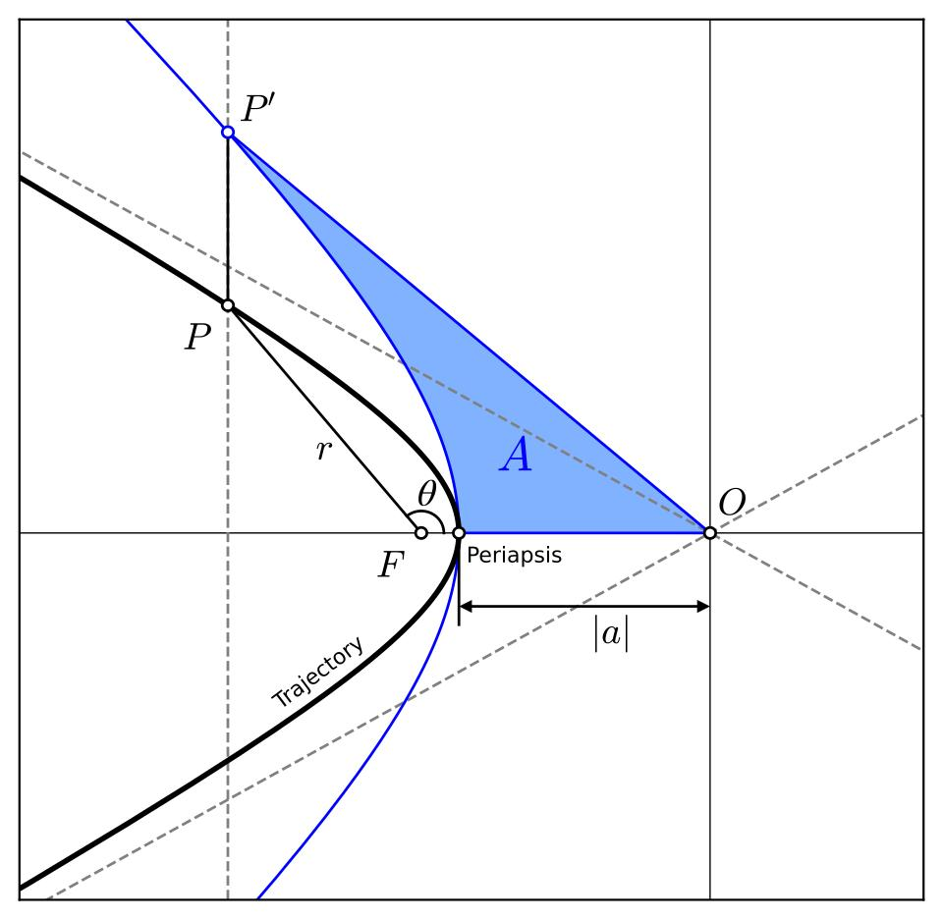
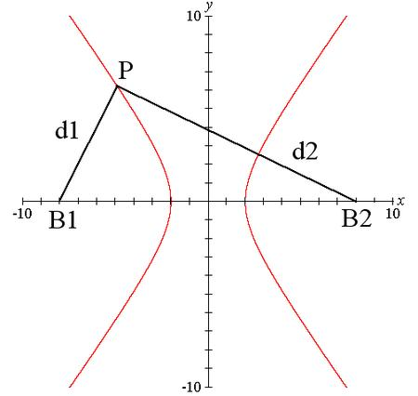
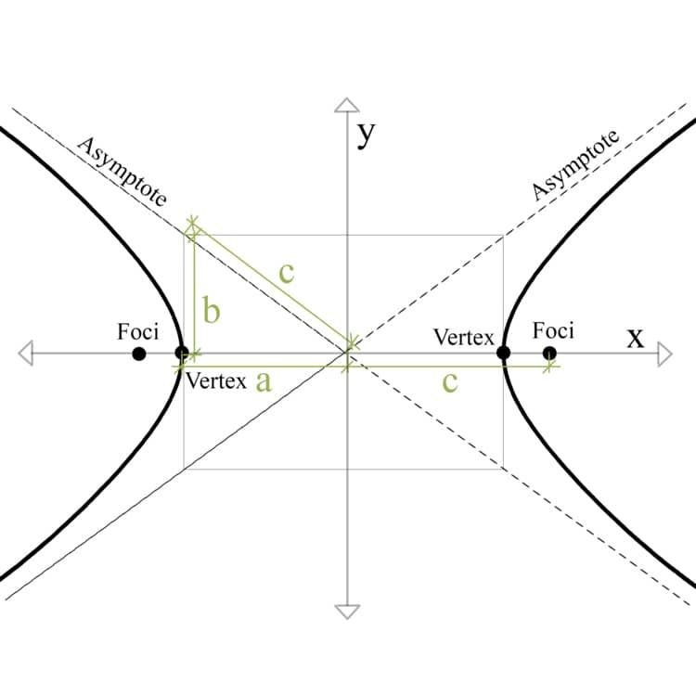
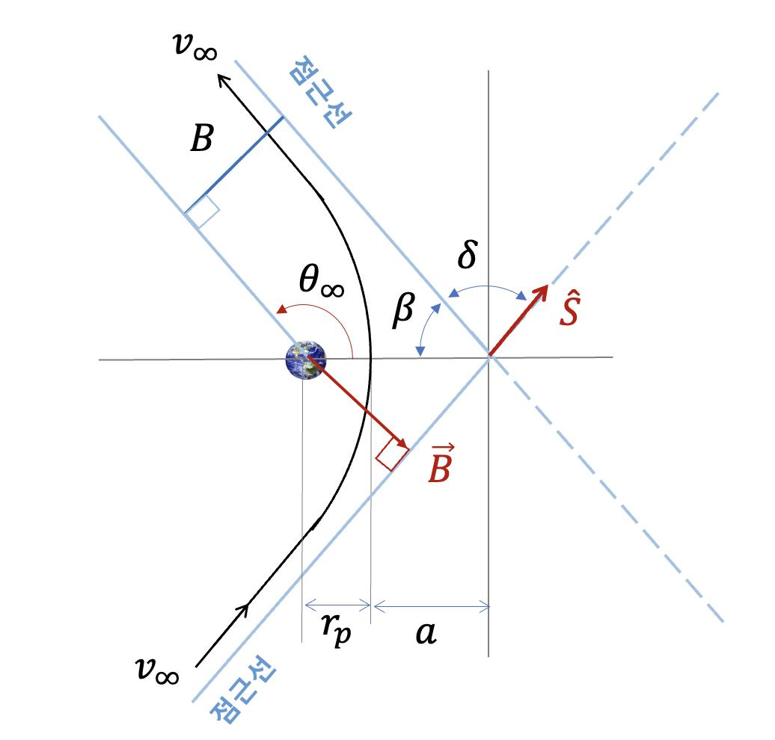
A Hyperbolic Path follows a hyperbola.
For foci $F_{1},F_{2}$,
$$\boxed{∣PF_{1}-PF_{2}∣=2a}$$
Standard Equation
$$\frac{x^{2}}{a^{2}}-\frac{y^{2}}{b^{2}}=1$$
Example
Certain idealized escape trajectories in orbital mechanics can be modeled by hyperbolic paths.
Important Property
A hyperbola normally consists of two separate branches.

5. Spiral Path
# Source: AI Source: Provided by: [Data Path: Persons Table -> ID Column: 1, Name_En Column: Motasem Essam] -> From: [ChatGPT] on [7/25/2026]
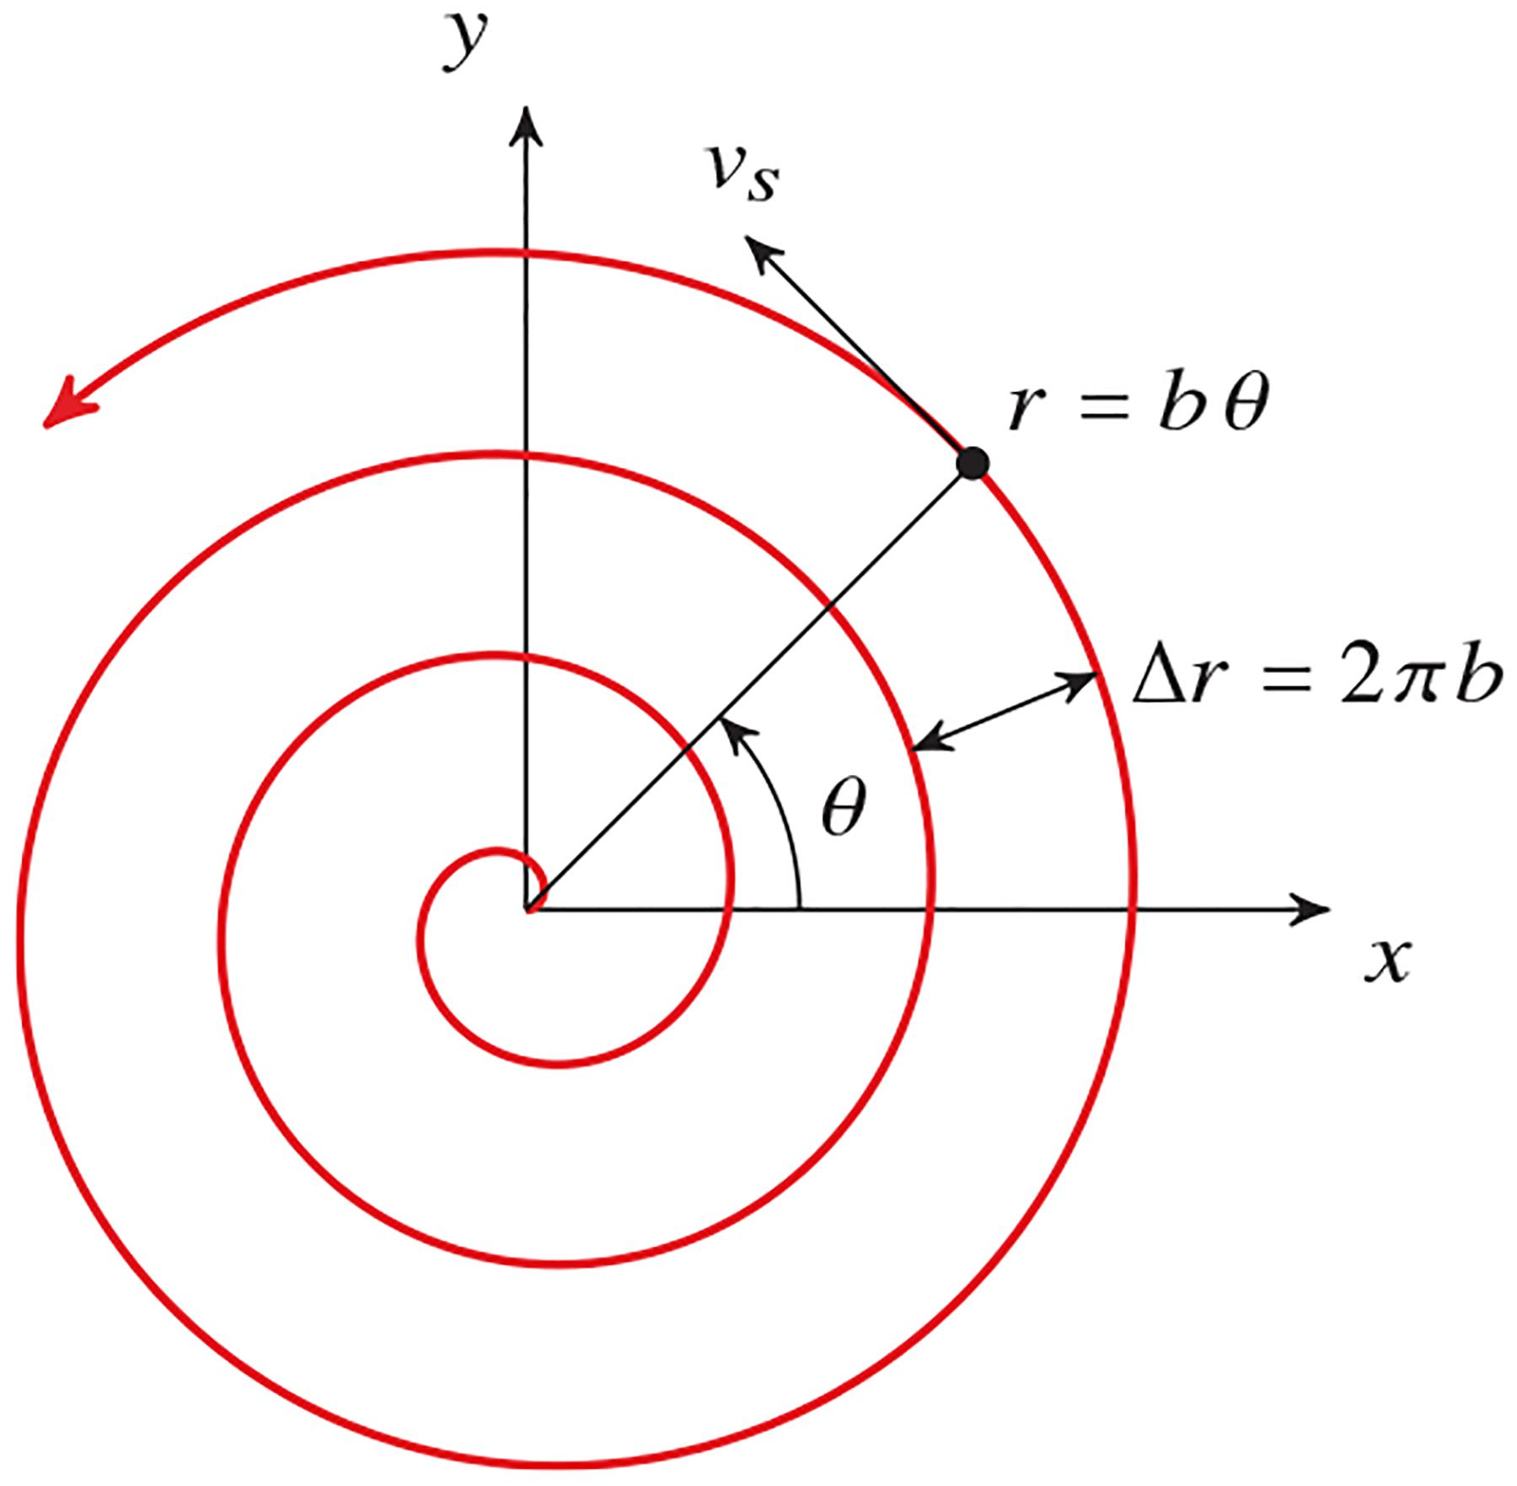
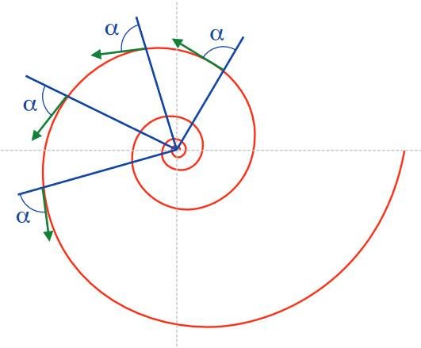
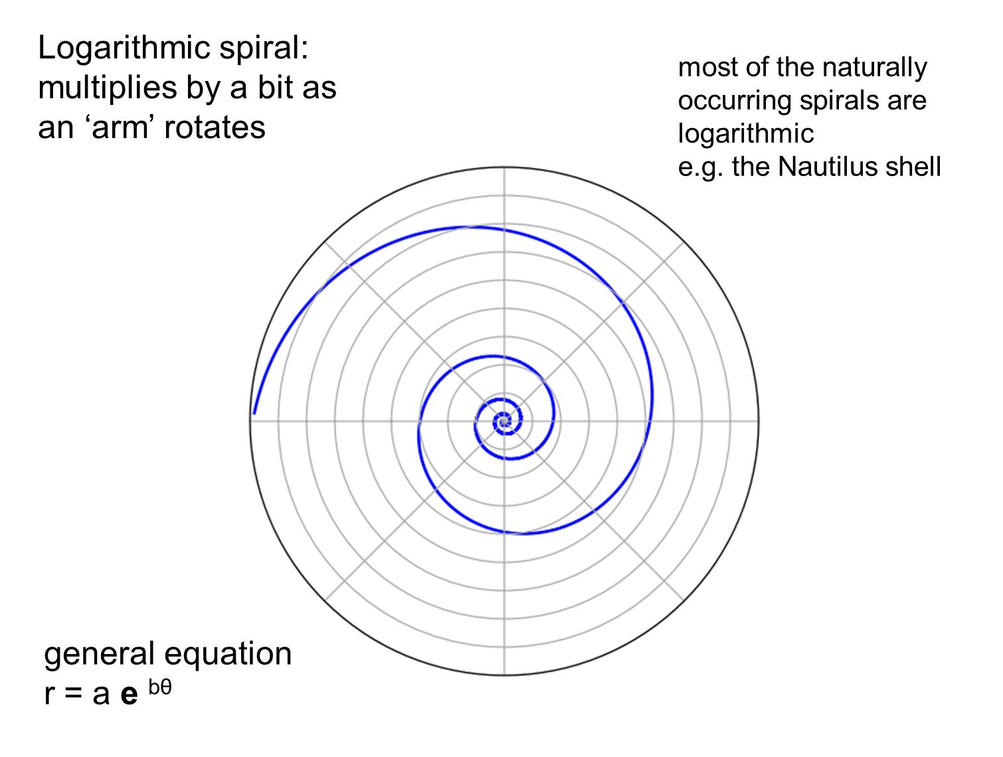
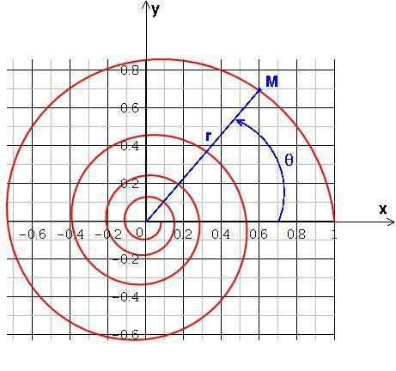
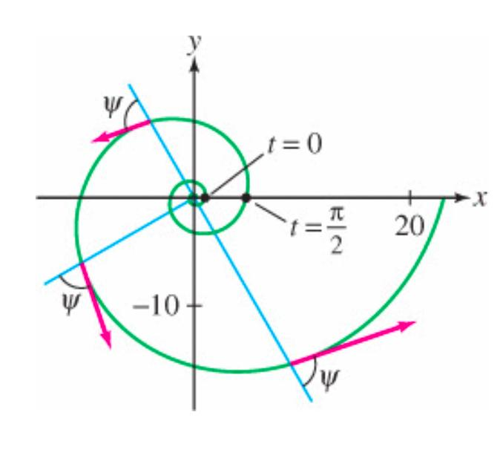
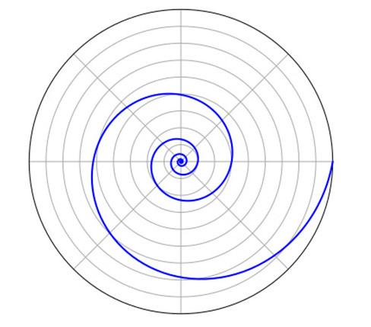
A Spiral Path is a curved path that winds around a central point while its distance from that point changes.
A polar representation can be written as
$$r=f\left(θ\right)$$
Example
A logarithmic spiral can be represented by
$$\boxed{r=ae^{bθ}}$$
As $θ$increases, the point moves around the center while its radius changes.
Important Property
Unlike a circular path,
$$r≠\text{constant}$$
in a typical spiral.

6. Sinusoidal Path
# Source: AI Source: Provided by: [Data Path: Persons Table -> ID Column: 1, Name_En Column: Motasem Essam] -> From: [ChatGPT] on [7/25/2026]
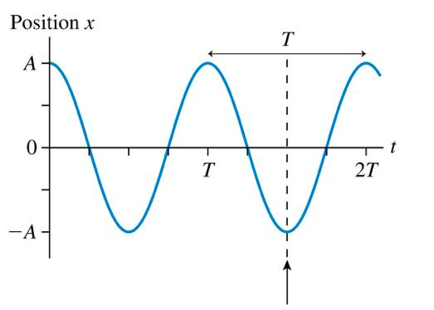
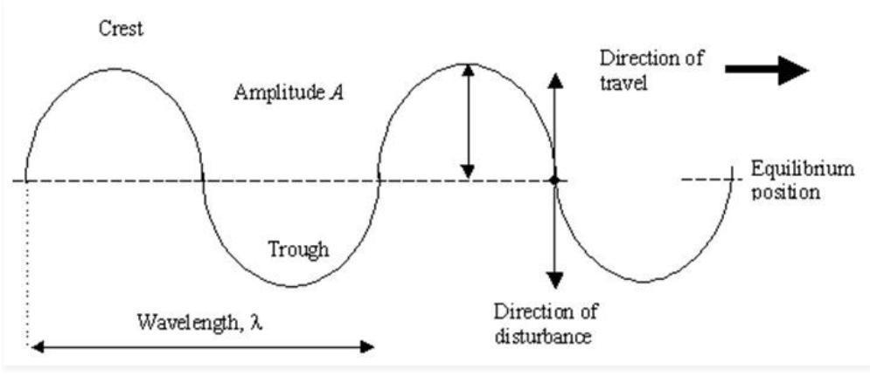
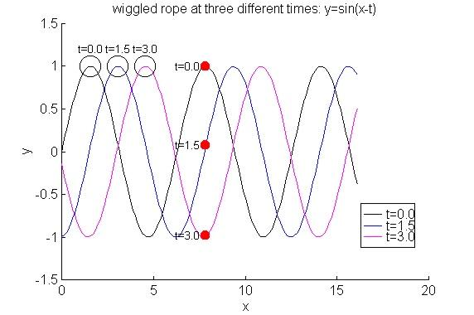
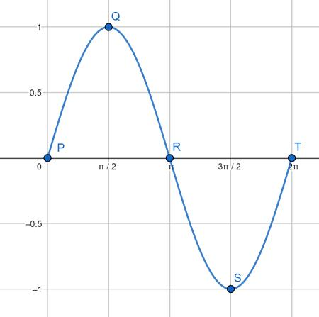
A Sinusoidal Path follows a sine or cosine curve.
A common equation is
$$\boxed{y=Asin⁡\left(Bx+C\right)+D}$$
where:
- $A$= amplitude
- $B$= frequency parameter
- $C$= phase shift
- $D$= vertical shift
Example
A point following
$$y=2\sin{x}$$
moves along a sinusoidal curved path.
Important Property
The path repeatedly rises and falls in a wave-like pattern.

7. Arc Path
# Source: AI Source: Provided by: [Data Path: Persons Table -> ID Column: 1, Name_En Column: Motasem Essam] -> From: [ChatGPT] on [7/25/2026]
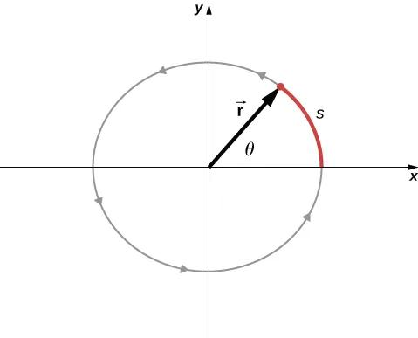
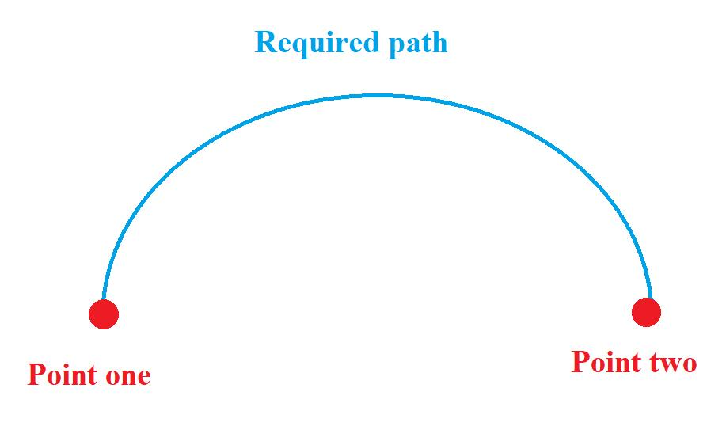
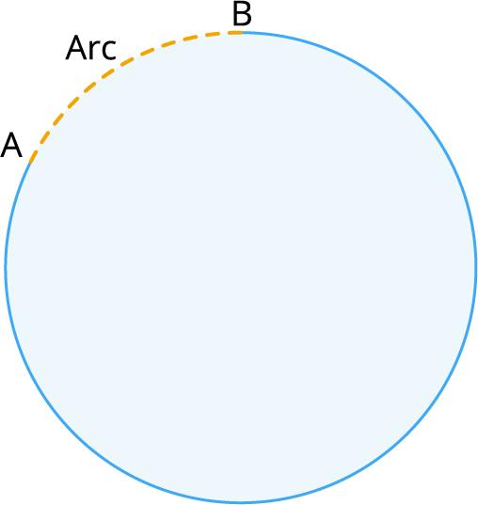
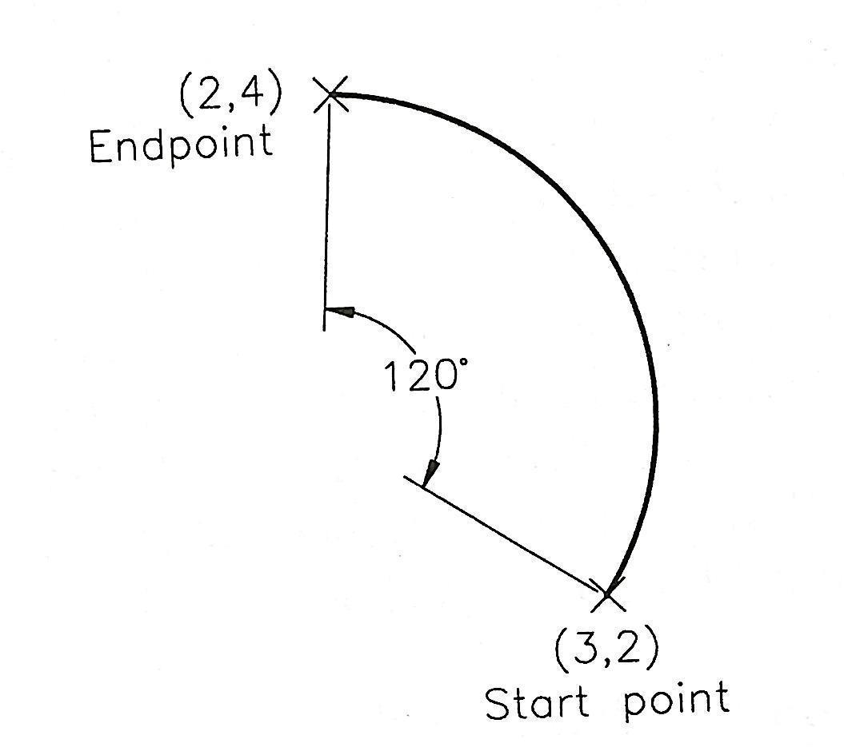
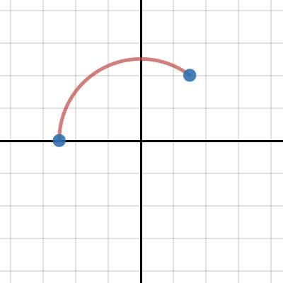
An Arc Path is a portion of a curved path between two points.
The arc may be part of:
- a circle
- an ellipse
- another curve
Example
A point moving from $A$to $B$along part of a circle follows a circular arc path.
For a circular arc,
$$\boxed{s=rθ}$$
where $θ$is measured in radians.

8. Smooth Curved Path
# Source: AI Source: Provided by: [Data Path: Persons Table -> ID Column: 1, Name_En Column: Motasem Essam] -> From: [ChatGPT] on [7/25/2026]
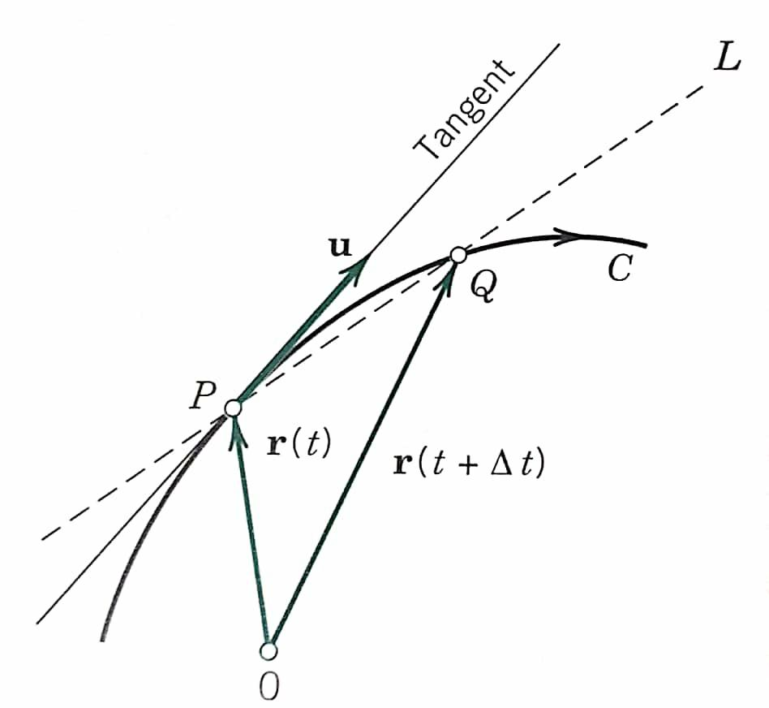
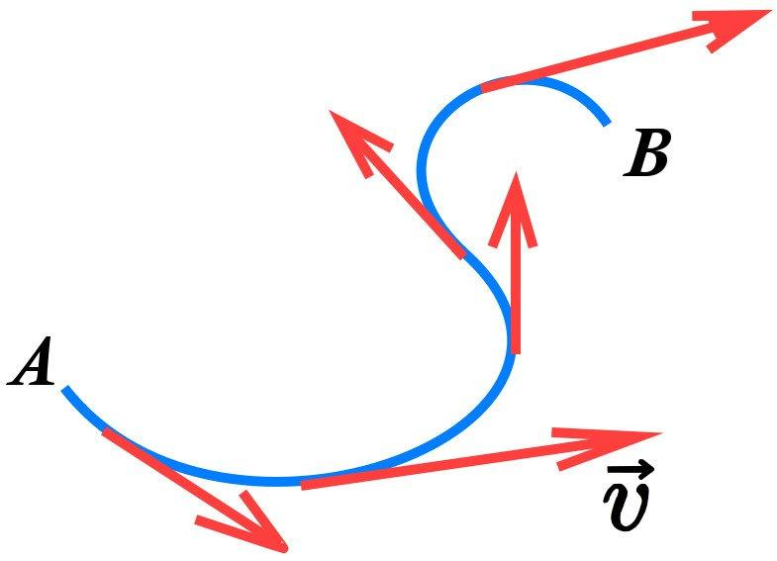
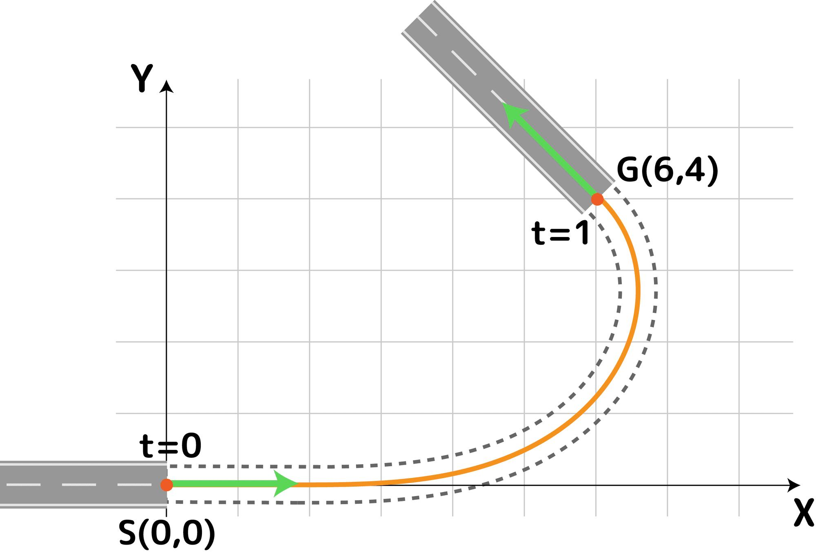
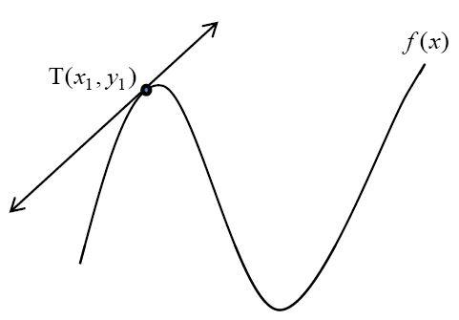
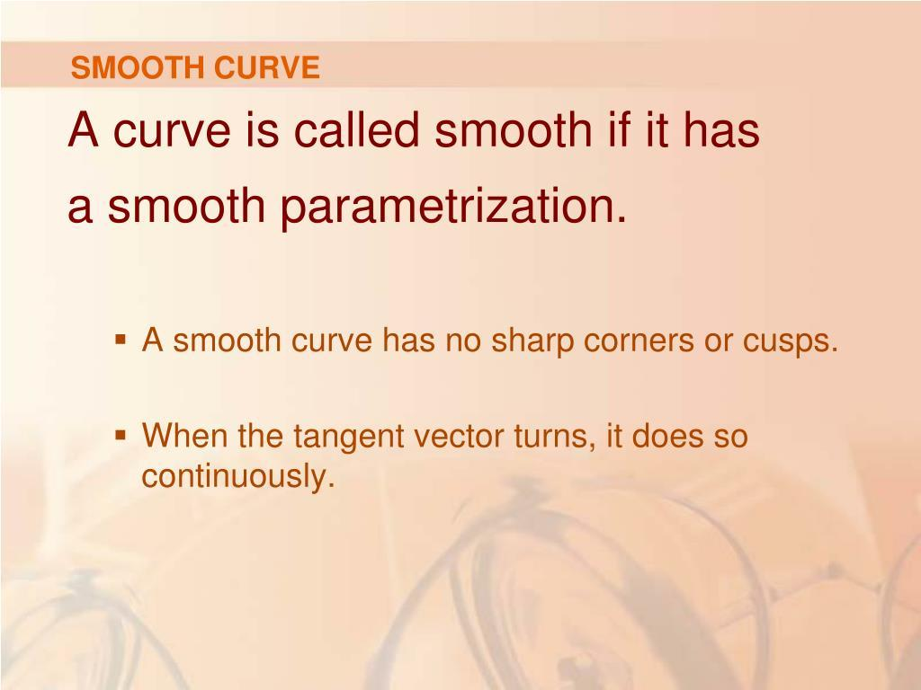
A Smooth Curved Path has no sharp corners or abrupt changes in direction.
Mathematically, its tangent direction changes continuously.
For a differentiable parametric curve,
$$r\left(t\right)=\left(x , \left(t\right)y\left(t\right)\right)$$
the tangent vector is
$$r^{'}\left(t\right).$$
Example
A circular arc is a smooth curved path.
Important Property
A smooth path can have continuously changing curvature.

9. Non-Smooth Curved Path
# Source: AI Source: Provided by: [Data Path: Persons Table -> ID Column: 1, Name_En Column: Motasem Essam] -> From: [ChatGPT] on [7/25/2026]
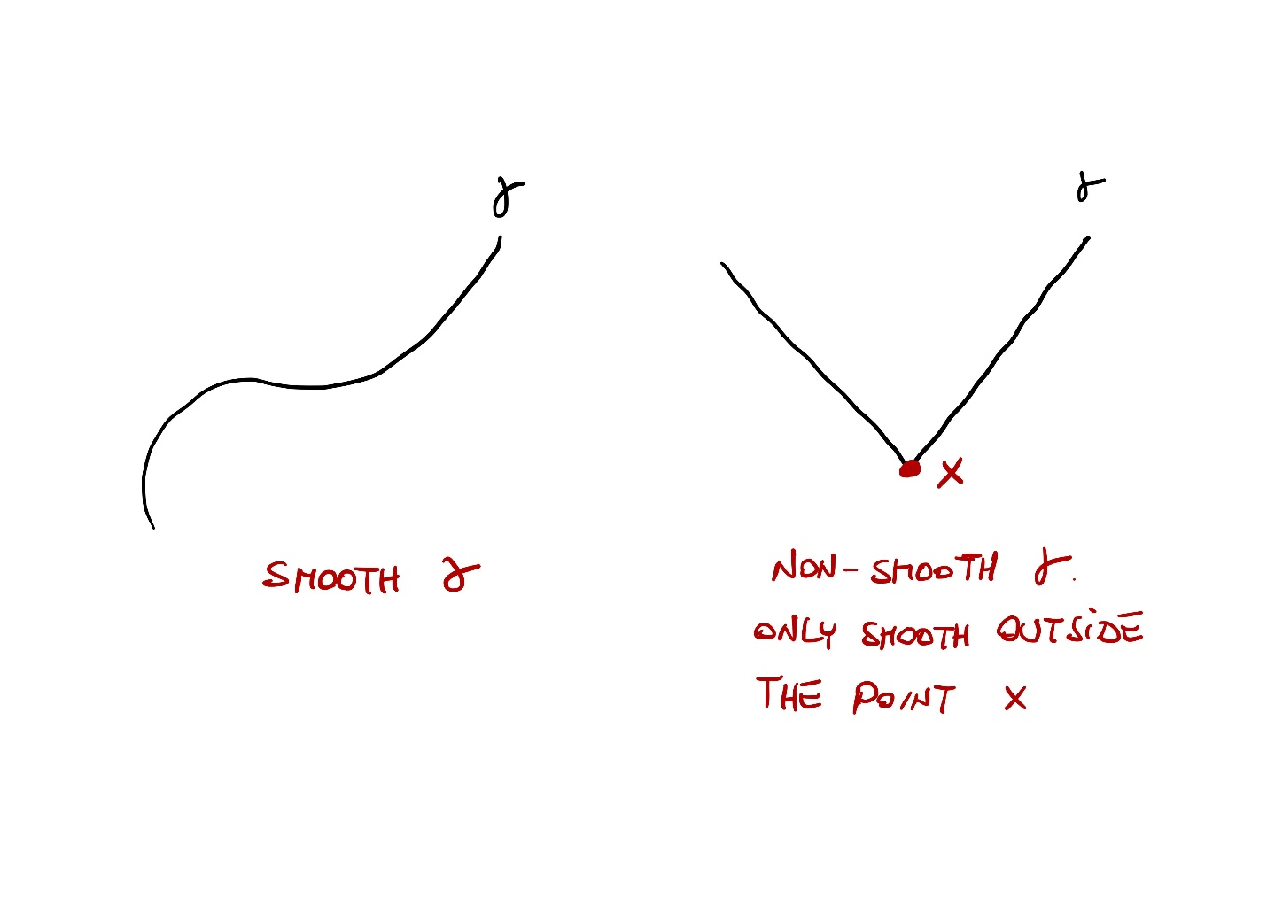
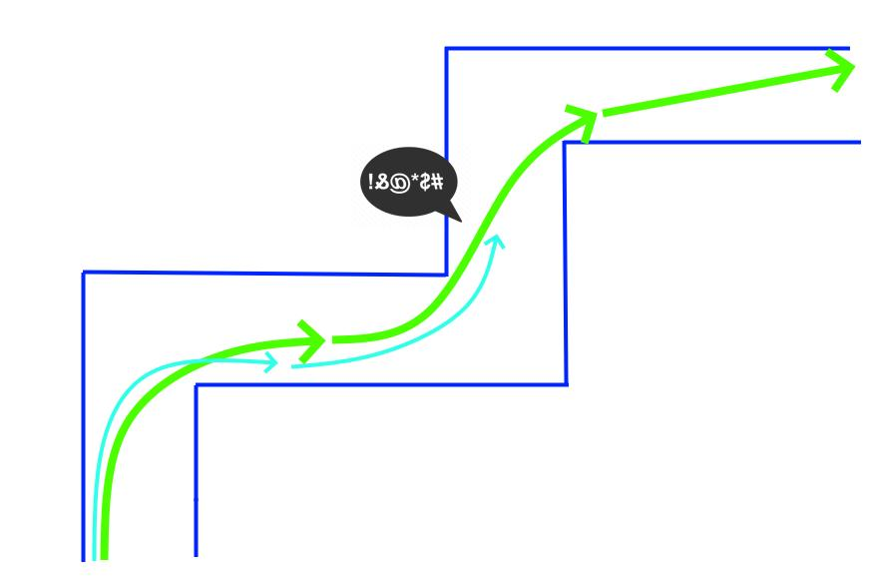
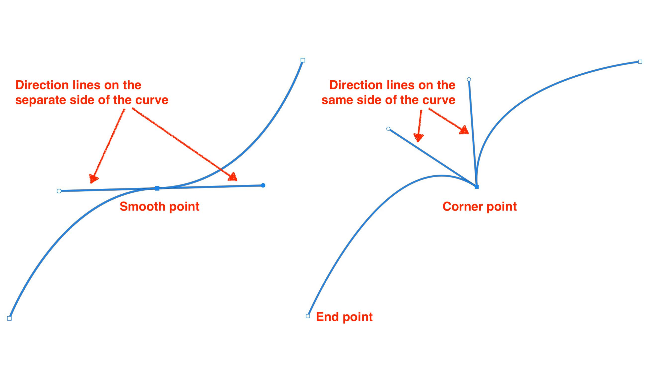
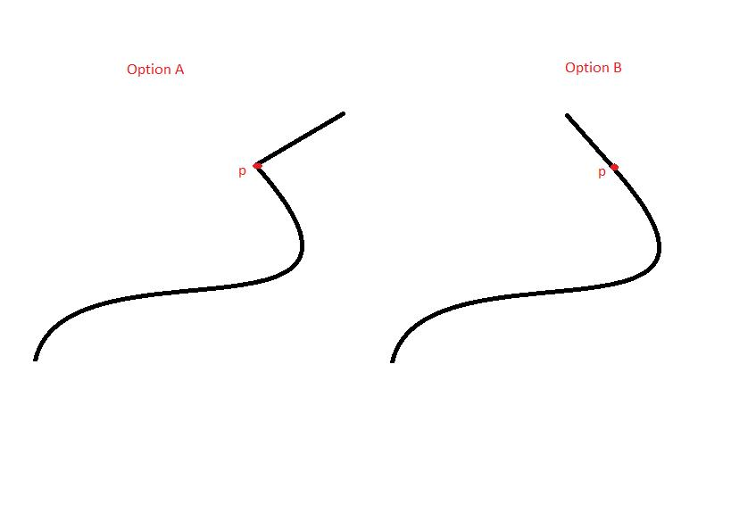
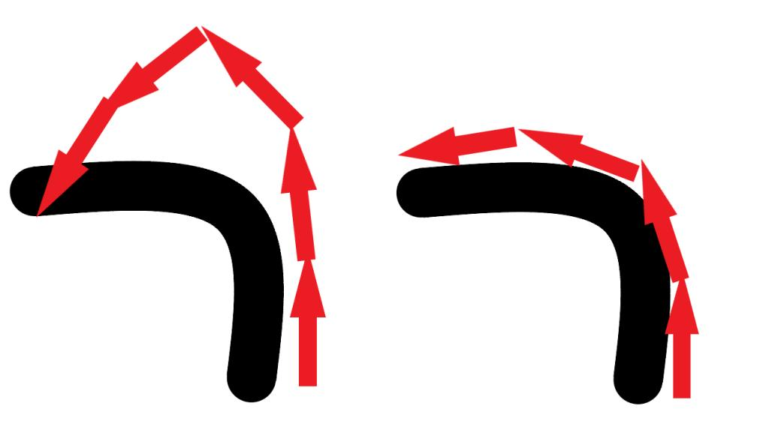
A Non-Smooth Curved Path contains at least one point where the tangent direction changes abruptly or where differentiability fails.
Example
Consider a path consisting of two curved arcs meeting at a sharp corner.
The path can be continuous:
$$P\left(t^{-}\right)=P\left(t^{+}\right)$$
while the tangent directions differ:
$$T_{1}≠T_{2}.$$
Important Distinction
$$\boxed{\text{Continuous}⇏\text{Smooth}}$$

10. Open Curved Path
# Source: AI Source: Provided by: [Data Path: Persons Table -> ID Column: 1, Name_En Column: Motasem Essam] -> From: [ChatGPT] on [7/25/2026]
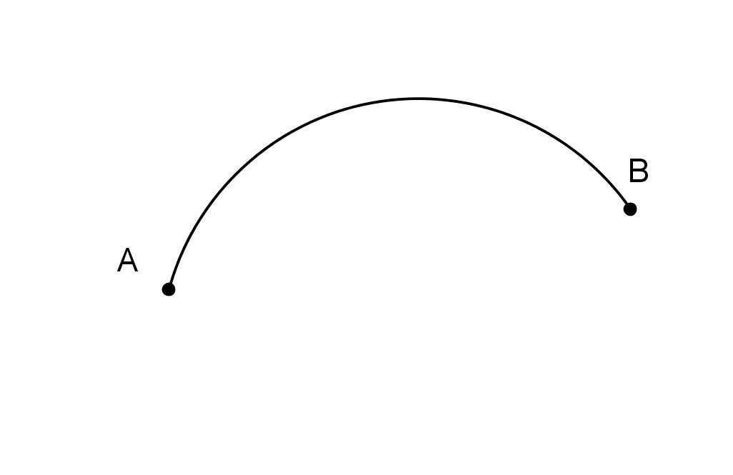
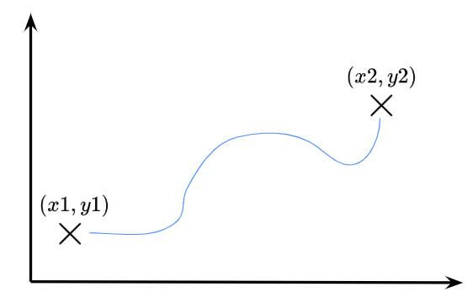
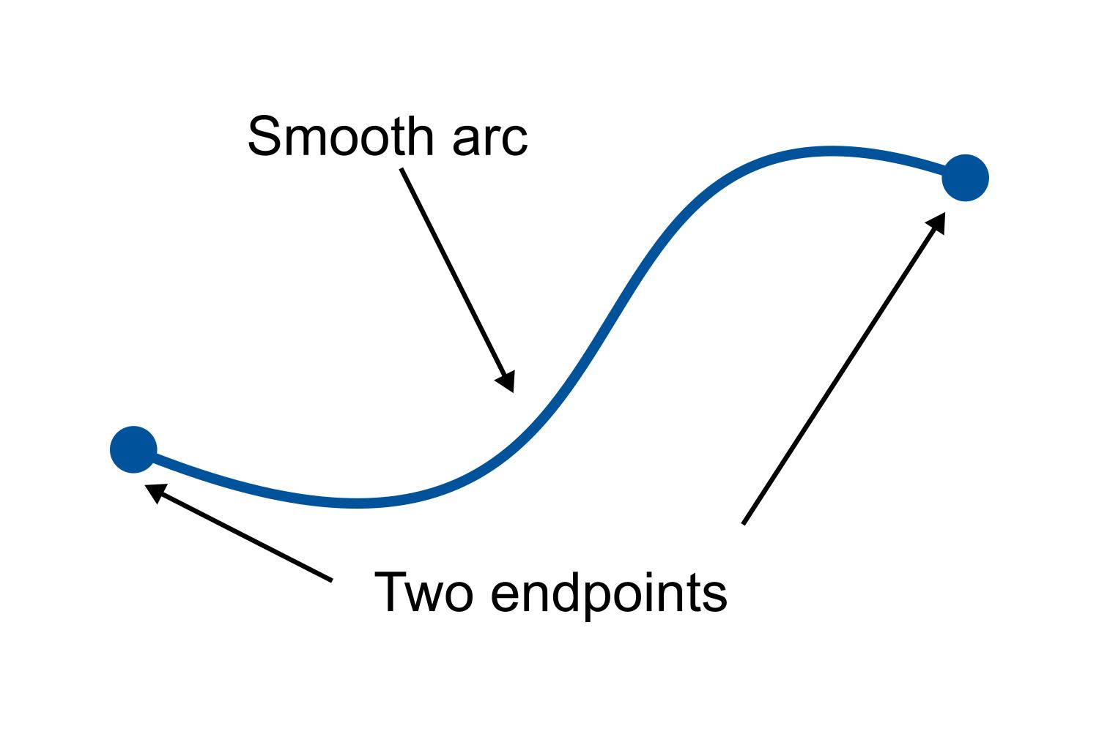
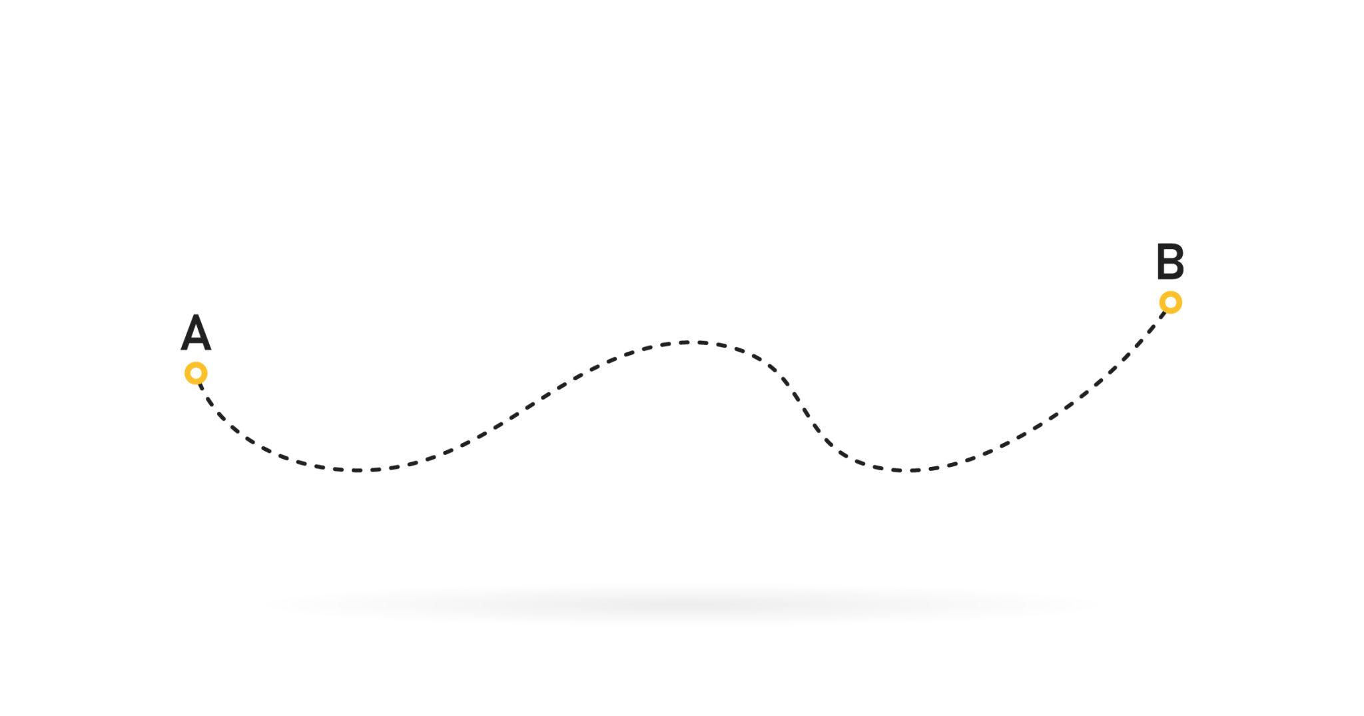
An Open Curved Path has distinct starting and ending points.
$$\boxed{P_{\text{start}}≠P_{\text{end}}}$$
Example
A parabolic arc from $A$to $B$is an open curved path.

11. Closed Curved Path
# Source: AI Source: Provided by: [Data Path: Persons Table -> ID Column: 1, Name_En Column: Motasem Essam] -> From: [ChatGPT] on [7/25/2026]
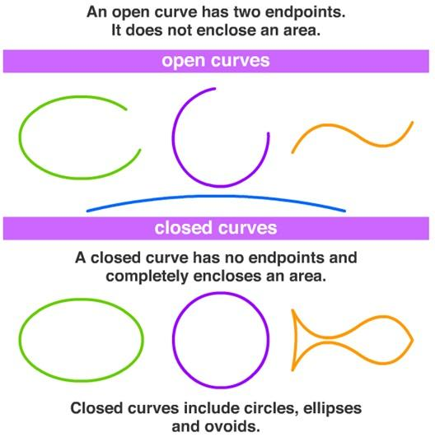
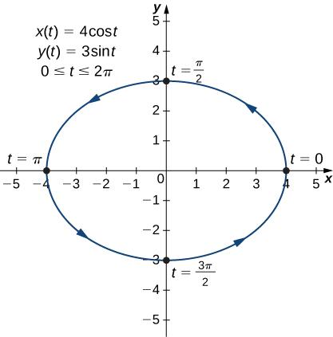
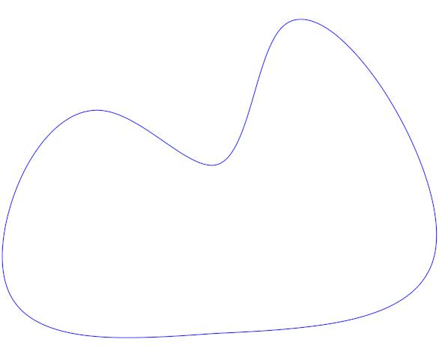
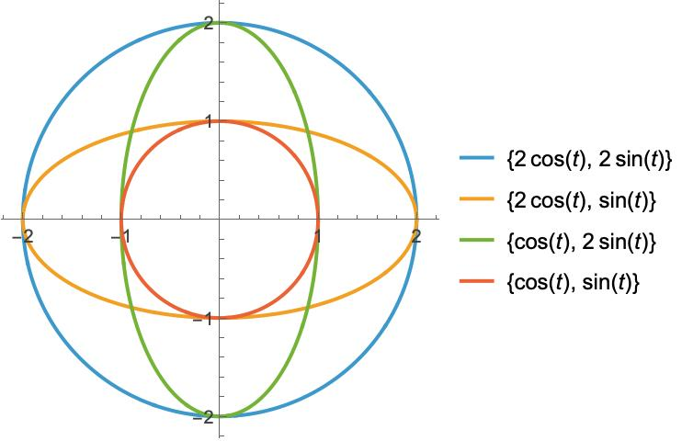
A Closed Curved Path returns to its starting point.
$$\boxed{P_{\text{start}}=P_{\text{end}}}$$
Examples
- circle
- ellipse
- closed smooth loop
A circle is both a curved path and a closed path.

12. Simple Curved Path
# Source: AI Source: Provided by: [Data Path: Persons Table -> ID Column: 1, Name_En Column: Motasem Essam] -> From: [ChatGPT] on [7/25/2026]
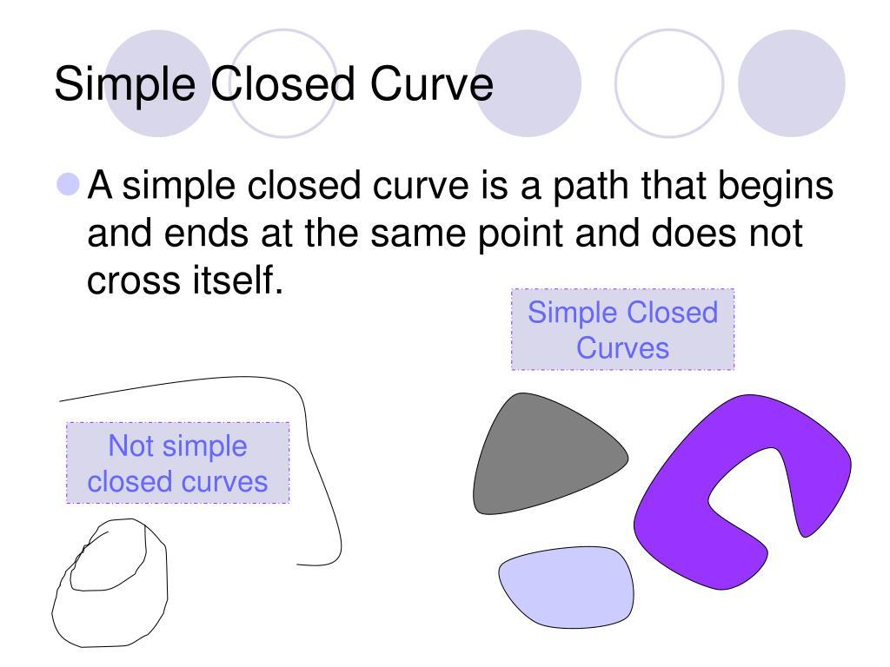
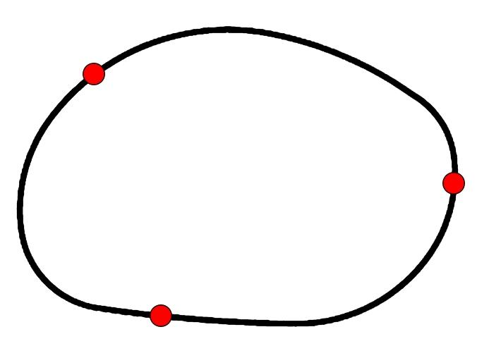
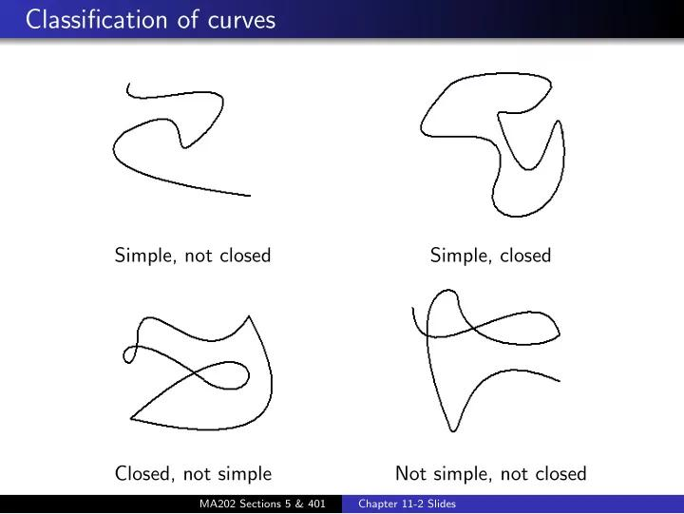
A Simple Curved Path does not cross itself.
For a simple parameterized curve, distinct parameter values generally do not represent the same point, except possibly when forming a closed curve at the initial/final point.
Example
An ellipse is a simple closed curved path.

13. Self-Intersecting Curved Path
# Source: AI Source: Provided by: [Data Path: Persons Table -> ID Column: 1, Name_En Column: Motasem Essam] -> From: [ChatGPT] on [7/25/2026]
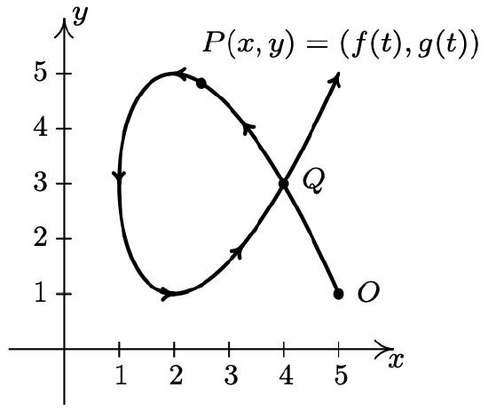
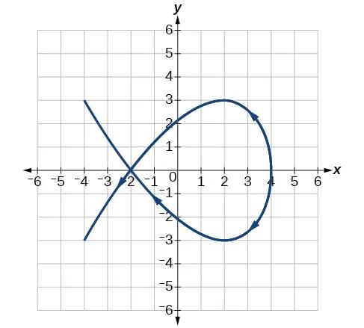
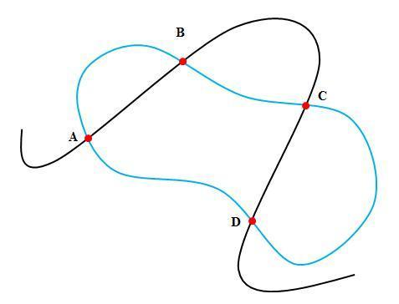
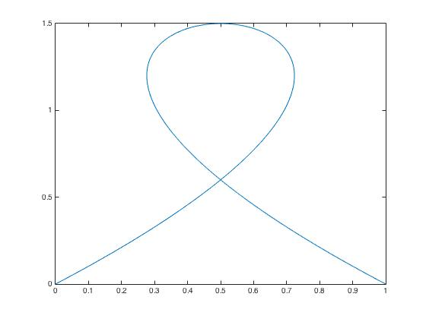
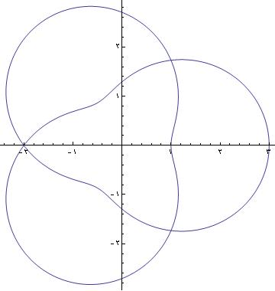
A Self-Intersecting Curved Path crosses itself at one or more points.
Example
A figure-eight-shaped curve can form a self-intersecting curved path.
If
$$P\left(t_{1}\right)=P\left(t_{2}\right), t_{1}≠t_{2},$$
then the curve has a repeated point.
Important Distinction
A curved path can be:
- simple
- self-intersecting
These are structural properties independent of whether the path is open or closed.

14. Parametric Curved Path
# Source: AI Source: Provided by: [Data Path: Persons Table -> ID Column: 1, Name_En Column: Motasem Essam] -> From: [ChatGPT] on [7/25/2026]
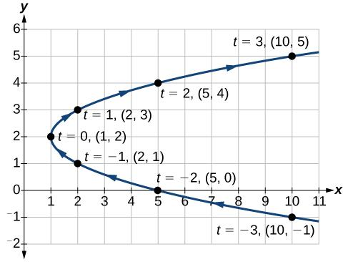
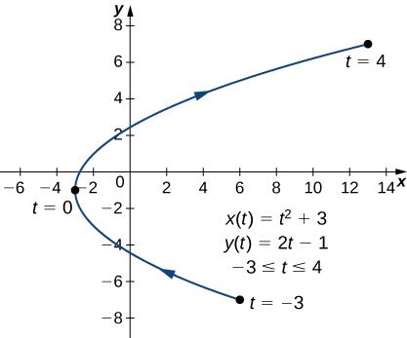
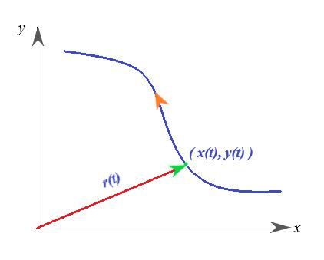
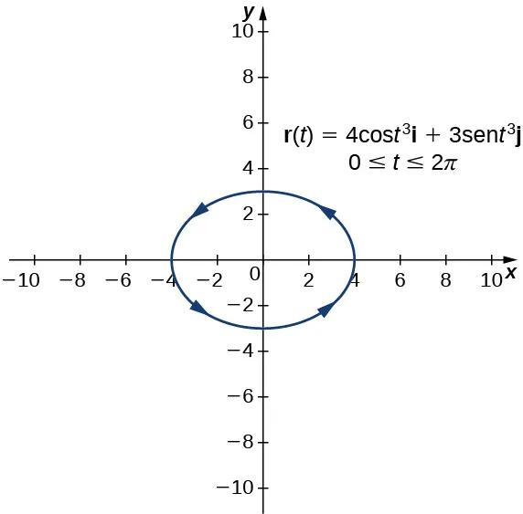
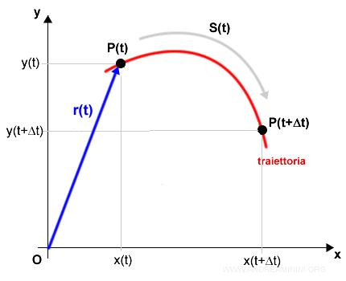
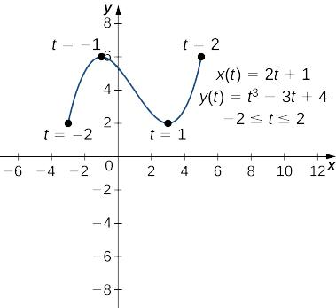
A Parametric Curved Path is represented using a parameter $t$.
$$\boxed{x=x\left(t\right), y=y\left(t\right)}$$
Example
A circular path can be represented as
$$x=\cos{t} \\ y=\sin{t}.$$
As $t$changes, the point traces the circle.
Advantage
Parametric equations naturally describe both the shape and the progression along the path.

15. Coordinate Curved Path
# Source: AI Source: Provided by: [Data Path: Persons Table -> ID Column: 1, Name_En Column: Motasem Essam] -> From: [ChatGPT] on [7/25/2026]
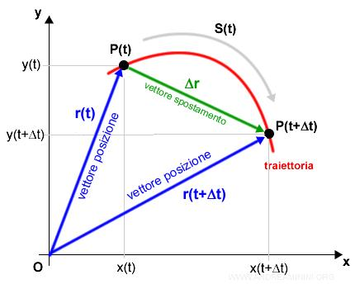
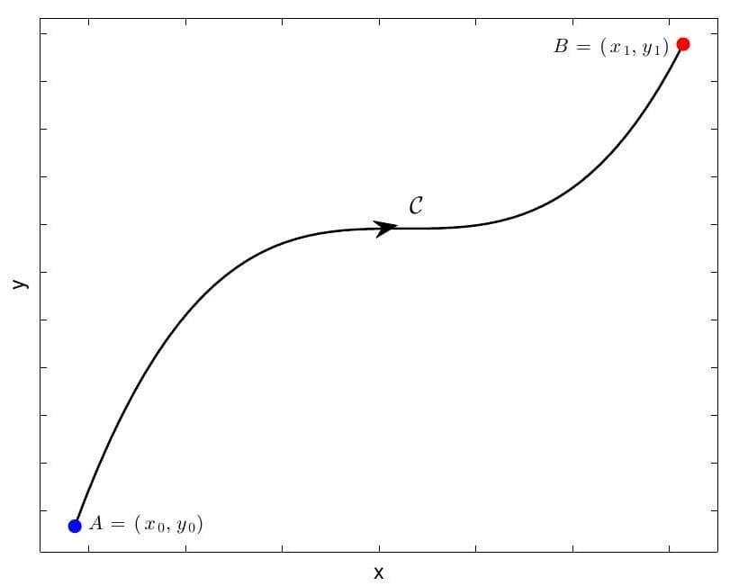
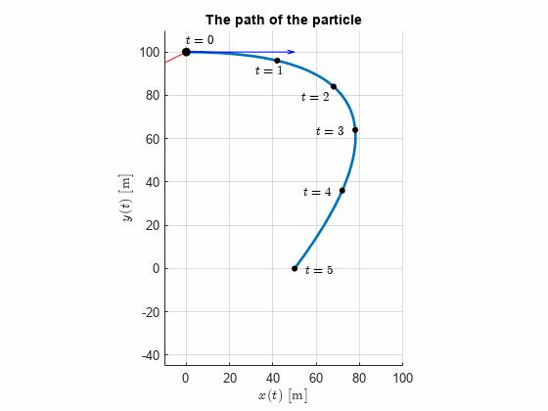
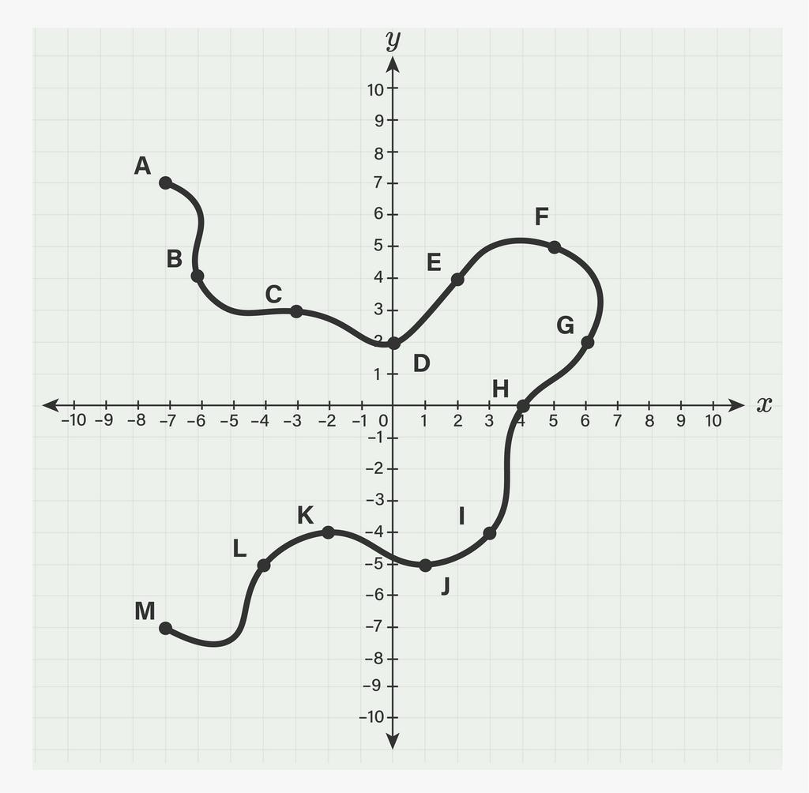
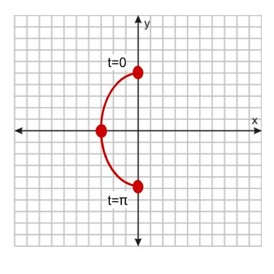
A Coordinate Curved Path is represented using an equation in a coordinate system.
Example
$$y=x^{2}$$
describes a parabolic path.
Another example is
$$x^{2}+y^{2}=25,$$
which describes a circular path.
Important Property
The coordinate equation determines which points belong to the path.

16. Vector-Defined Curved Path
# Source: AI Source: Provided by: [Data Path: Persons Table -> ID Column: 1, Name_En Column: Motasem Essam] -> From: [ChatGPT] on [7/25/2026]
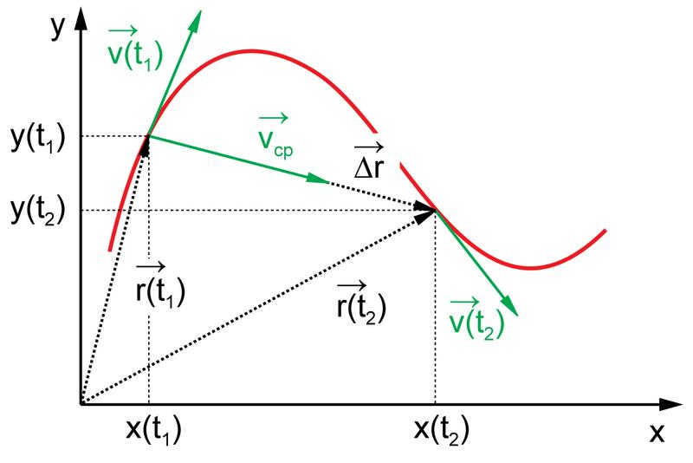
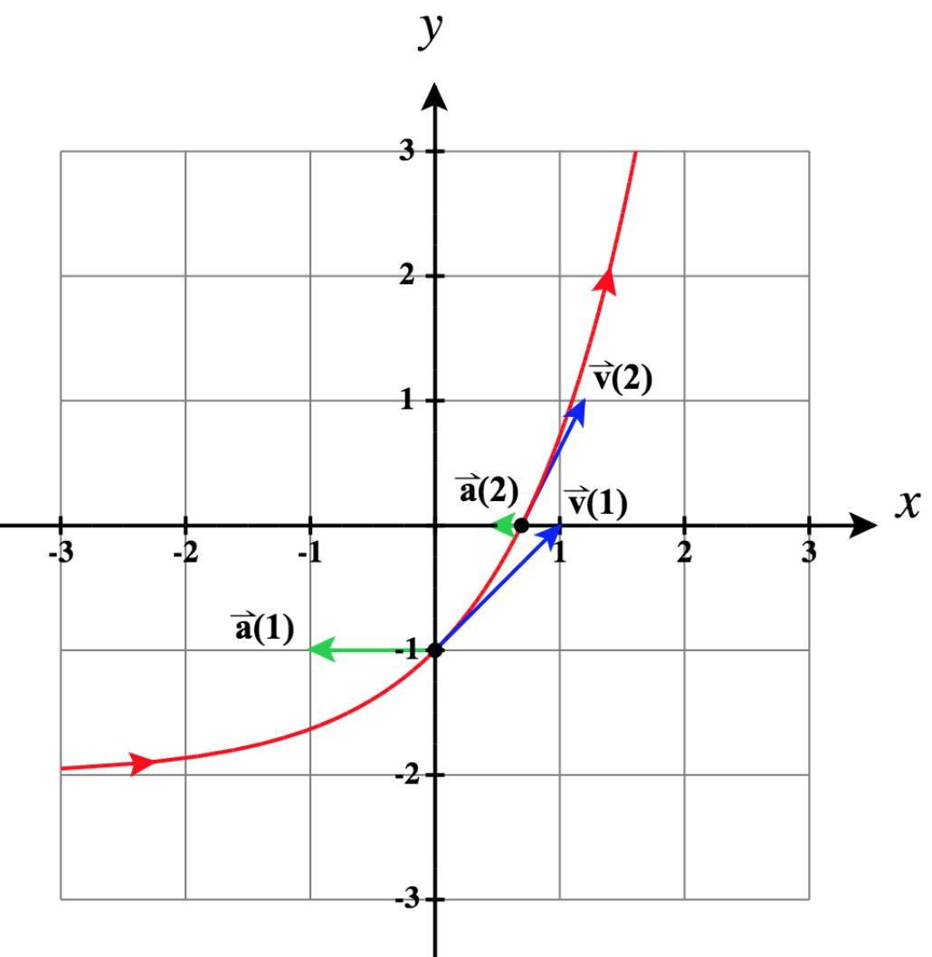
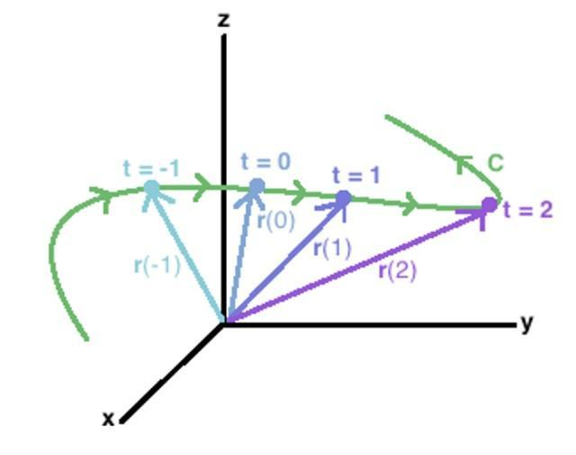
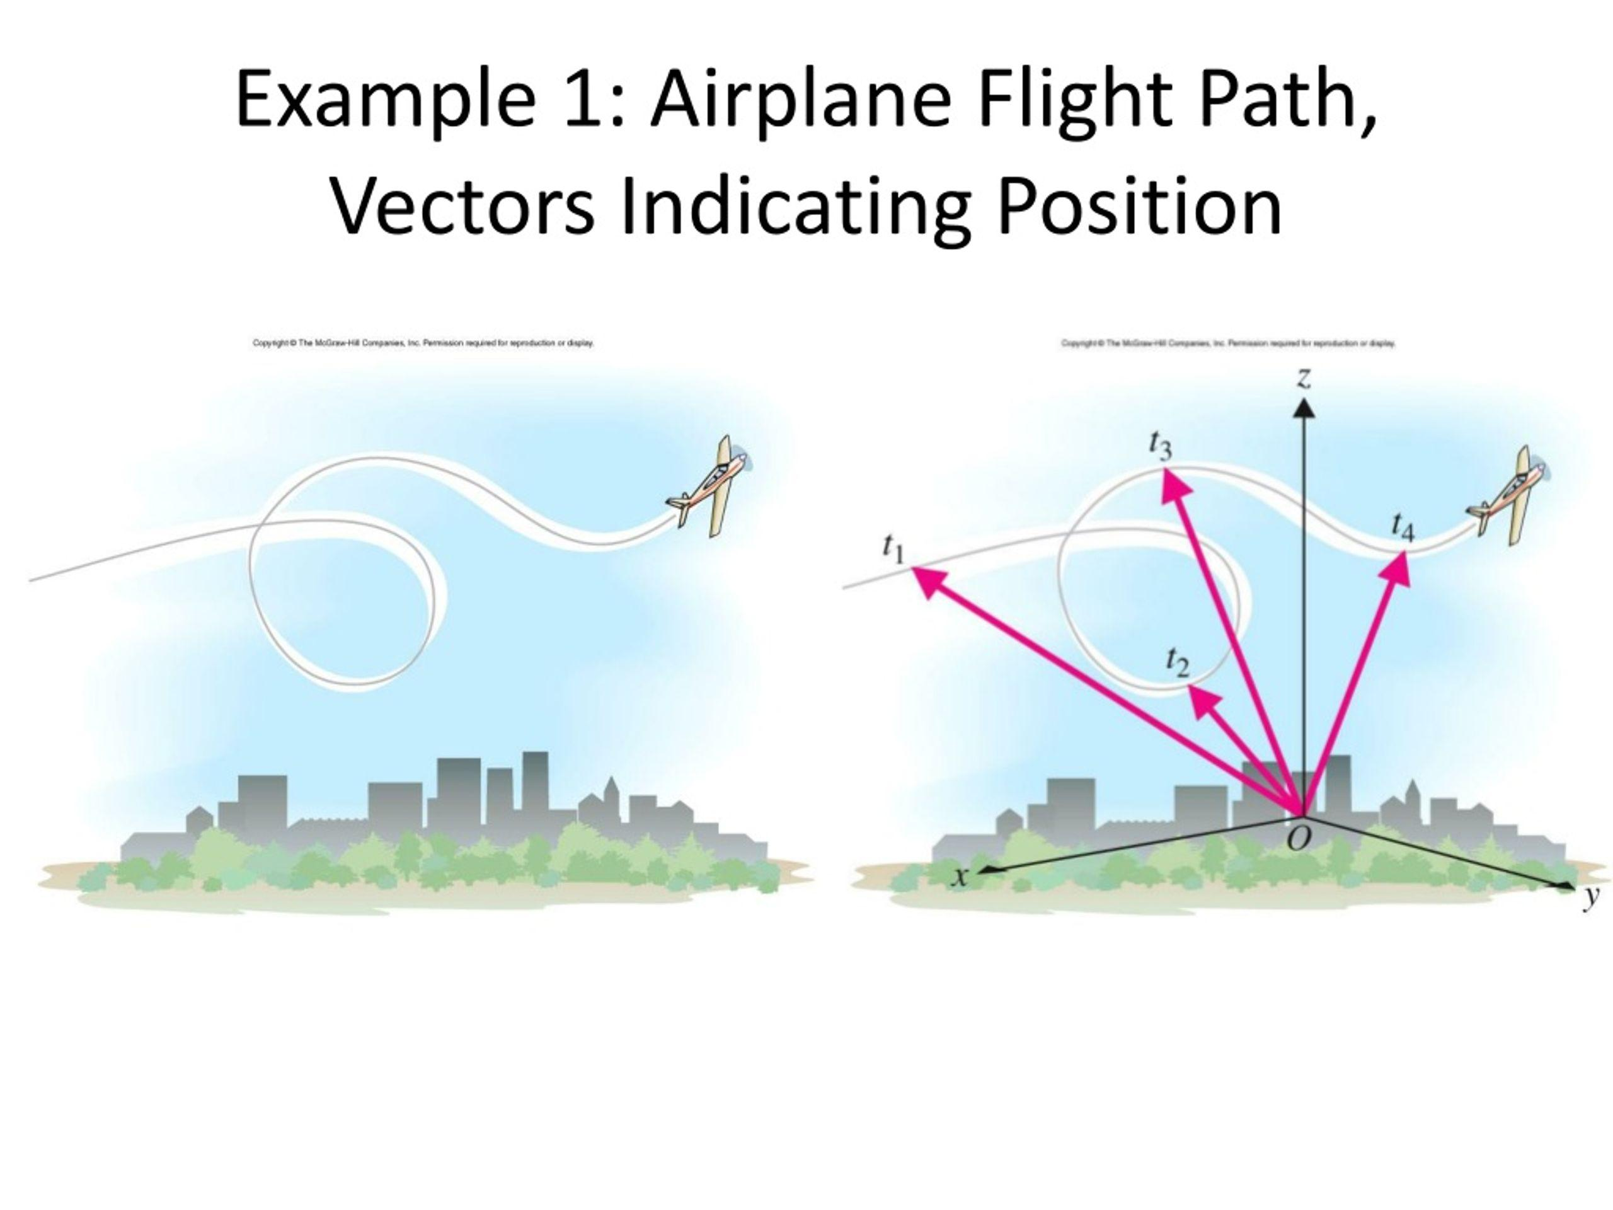
A Vector-Defined Curved Path represents the position of a moving point using a vector-valued function.
$$\boxed{r\left(t\right)=\left\langle x , \left(t\right)y\left(t\right)\right\rangle }$$
or in three dimensions,
$$\boxed{r\left(t\right)=\left\langle x , \left(t\right) , y\left(t\right)z\left(t\right)\right\rangle }.$$
Example
$$r\left(t\right)=\left\langle \cos{t} , \sin{t}\right\rangle$$
represents a circular path.
A more general example:
$$r\left(t\right)=\left\langle t , t^{2}\right\rangle$$
represents a parabolic path.

17. Restricted Curved Path
# Source: AI Source: Provided by: [Data Path: Persons Table -> ID Column: 1, Name_En Column: Motasem Essam] -> From: [ChatGPT] on [7/25/2026]
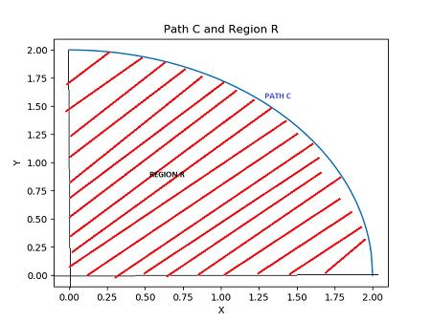
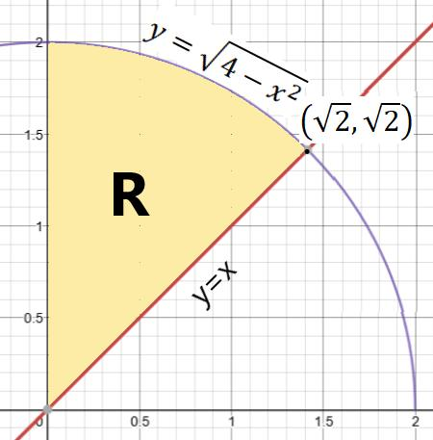
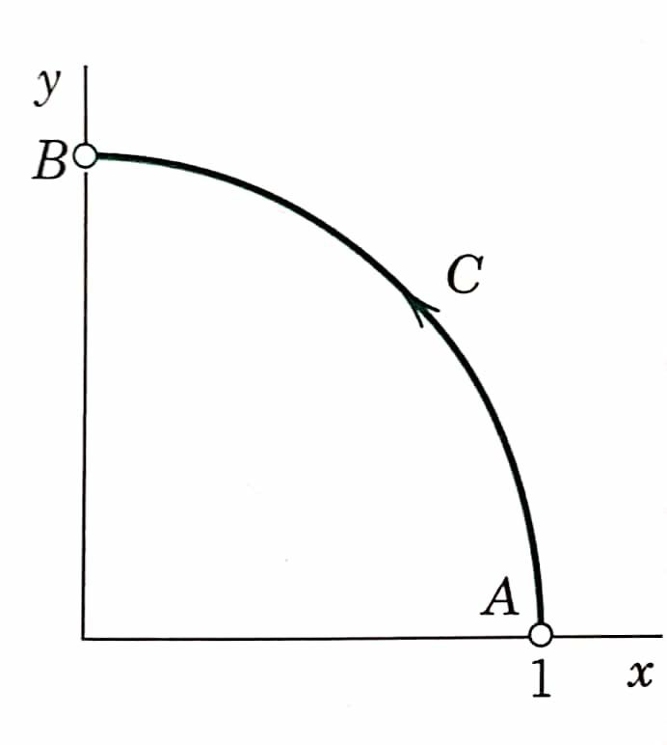
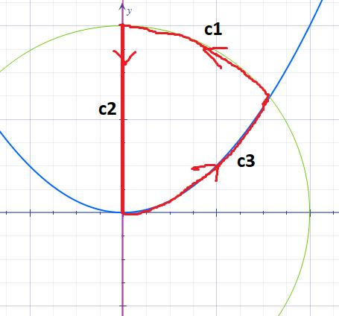
A Restricted Curved Path is a curved path whose allowable points are limited by additional conditions.
For example,
$$y=x^{2}, 0≤x≤3.$$
Instead of the entire parabola, only one portion is used.
Example
$$P=\left\{\left(x , x^{2}\right):0≤x≤3\right\}.$$
This is a restricted parabolic path.

18. Monotone Curved Path
# Source: AI Source: Provided by: [Data Path: Persons Table -> ID Column: 1, Name_En Column: Motasem Essam] -> From: [ChatGPT] on [7/25/2026]
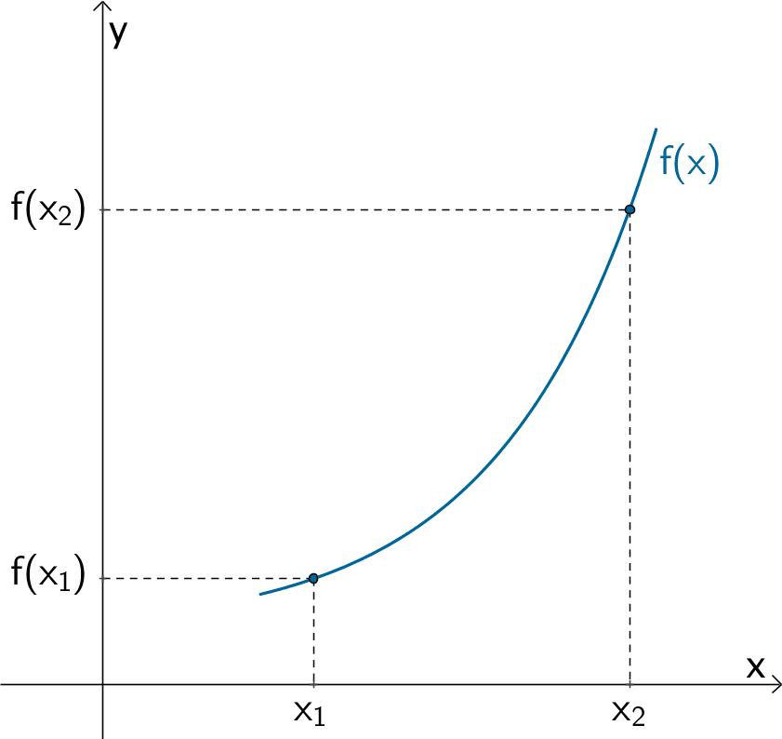
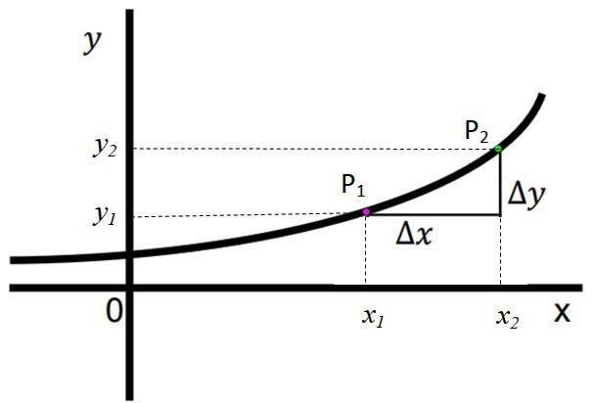
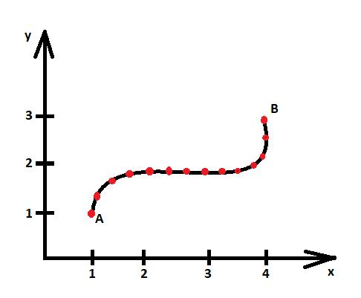
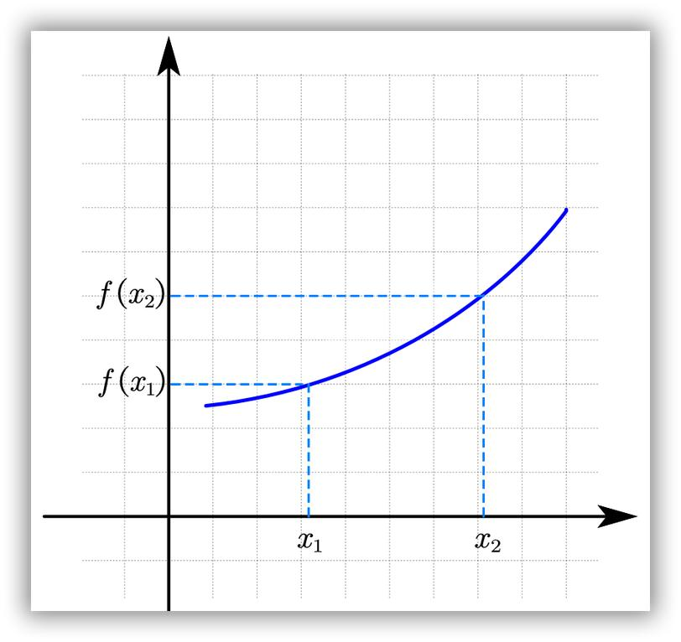
A Monotone Curved Path progresses consistently in a particular coordinate direction.
For example, an $x$-monotone path does not move backward in $x$.
If
$$x\left(t_{2}\right)≥x\left(t_{1}\right)$$
whenever
$$t_{2}>t_{1},$$
then the path is $x$-monotone.
Example
$$y=x^{2}, x≥0$$
is $x$-monotone when traversed from left to right.

19. Piecewise-Curved Path
# Source: AI Source: Provided by: [Data Path: Persons Table -> ID Column: 1, Name_En Column: Motasem Essam] -> From: [ChatGPT] on [7/25/2026]
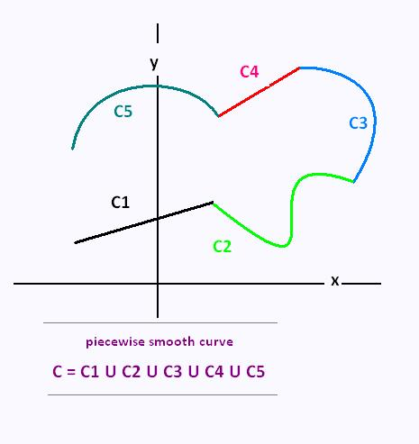
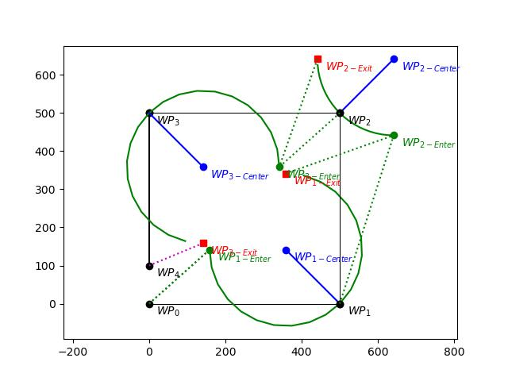
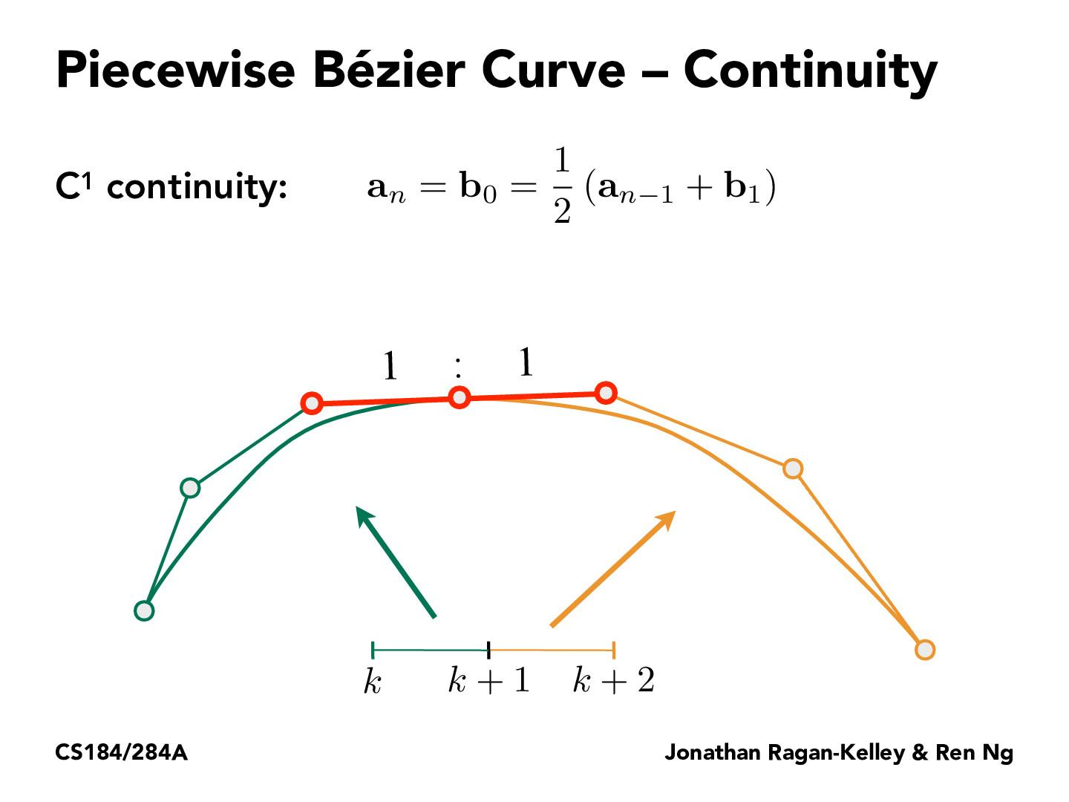
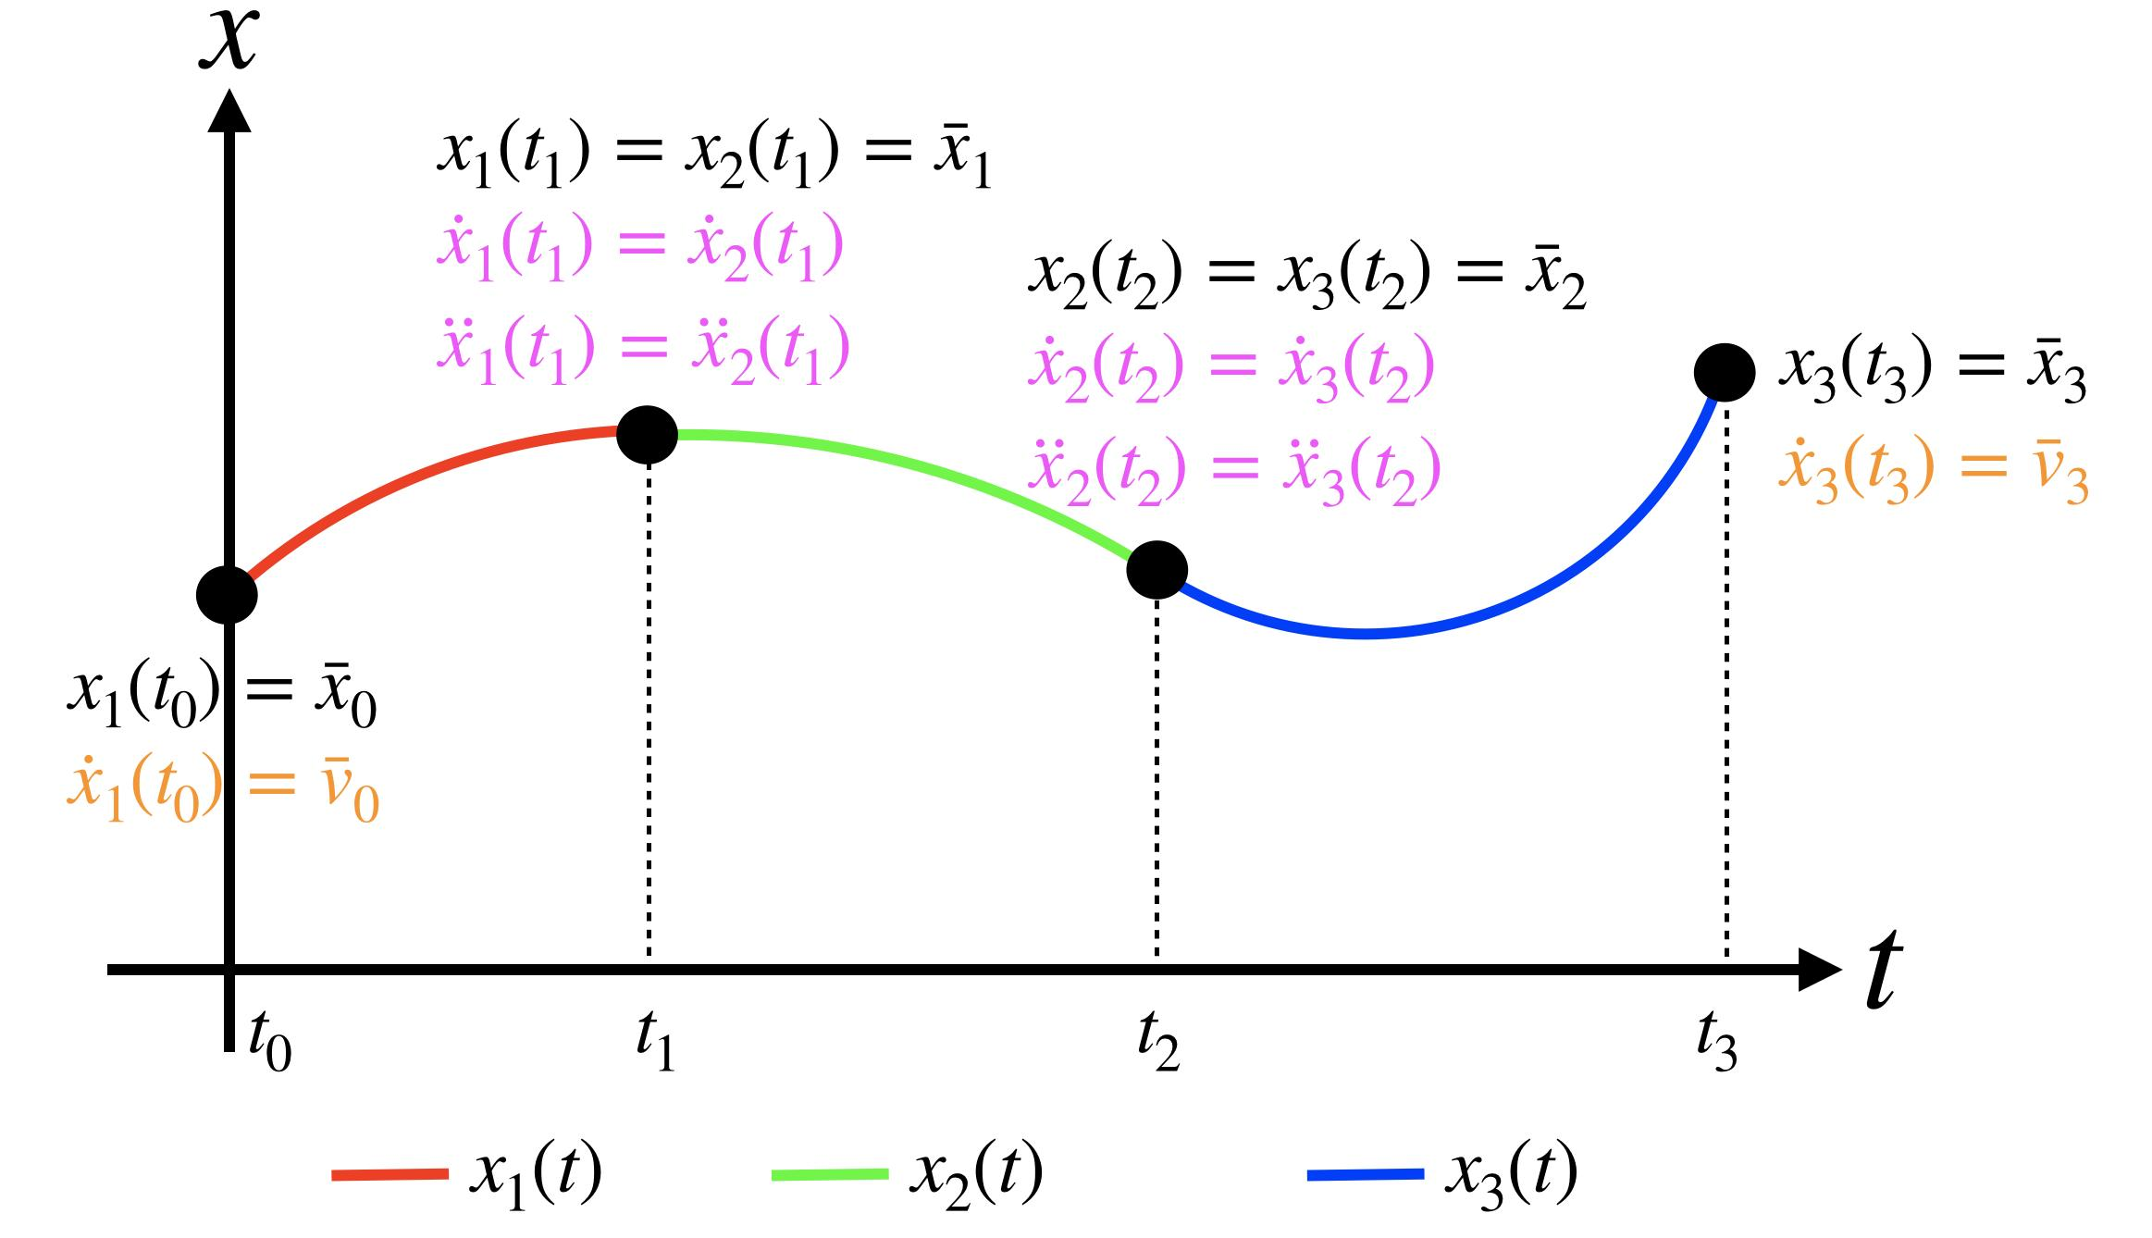
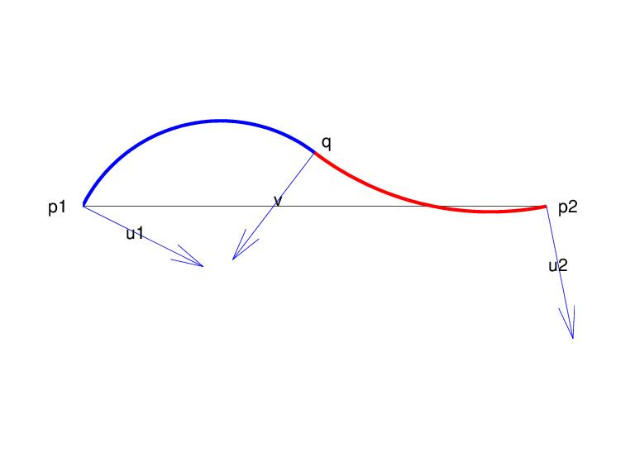
A Piecewise-Curved Path consists of several connected curved pieces.
$$\boxed{P=P_{1}∪P_{2}∪⋯∪P_{n}}$$
Each $P_{i}$can follow a different curved equation.
Example
$$\text{Circular Arc}→\text{Parabolic Arc}→\text{Elliptical Arc}$$
Important Property
The pieces may be:
- continuous but non-smooth,
- continuous and smooth,
- or even disconnected if continuity is not required.

20. Combined Curved Path
# Source: AI Source: Provided by: [Data Path: Persons Table -> ID Column: 1, Name_En Column: Motasem Essam] -> From: [ChatGPT] on [7/25/2026]
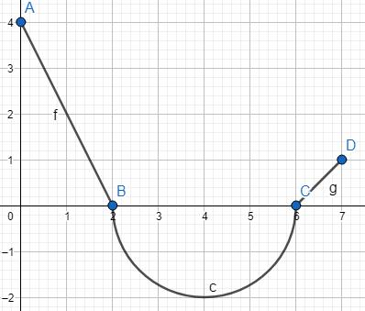
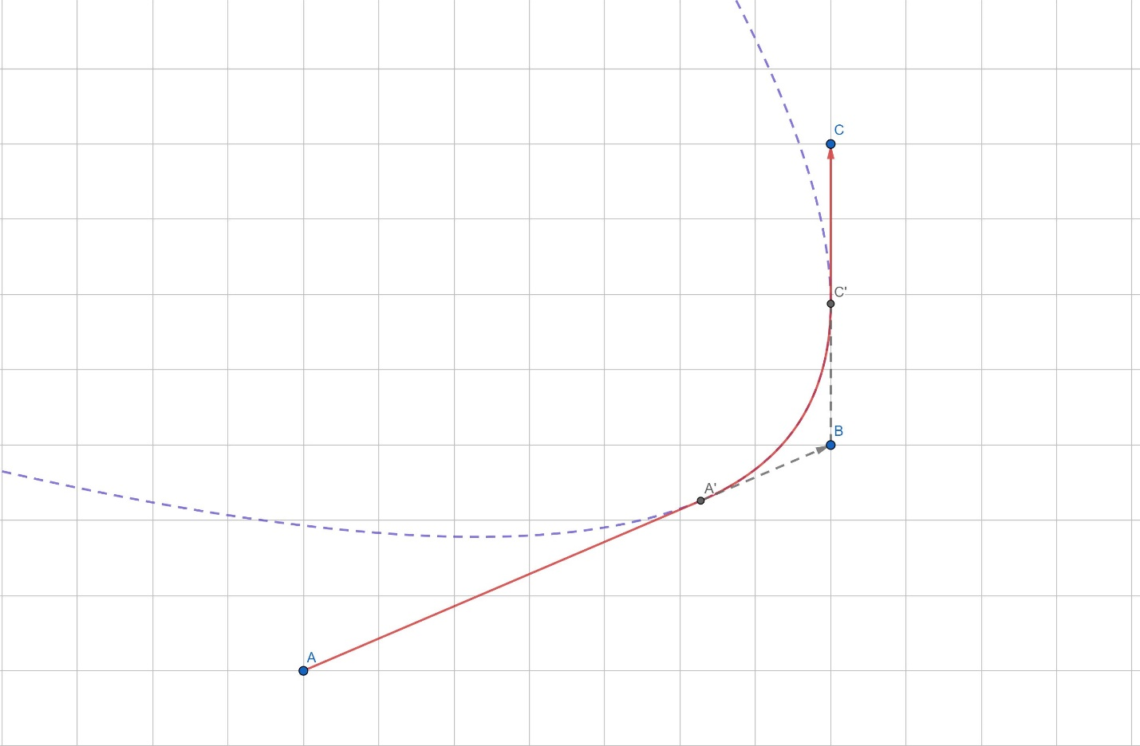
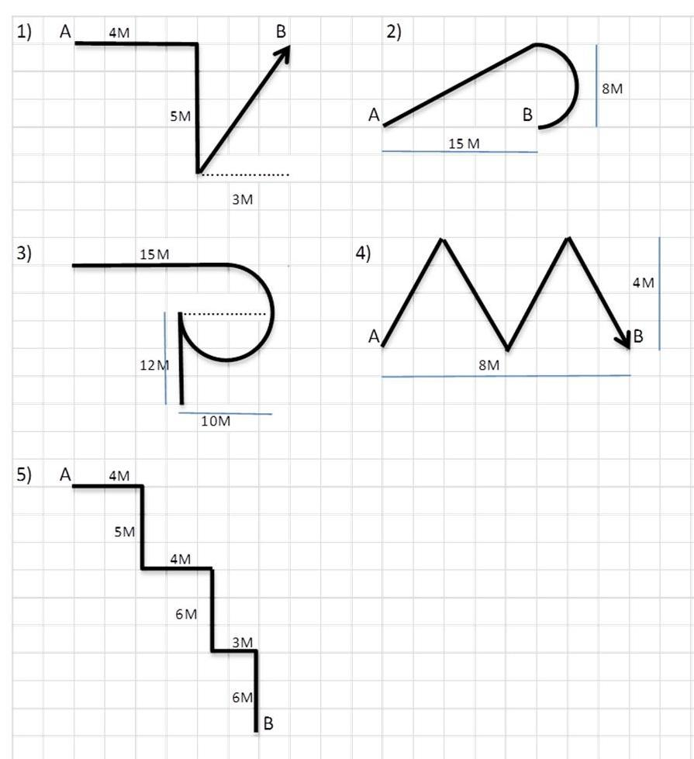
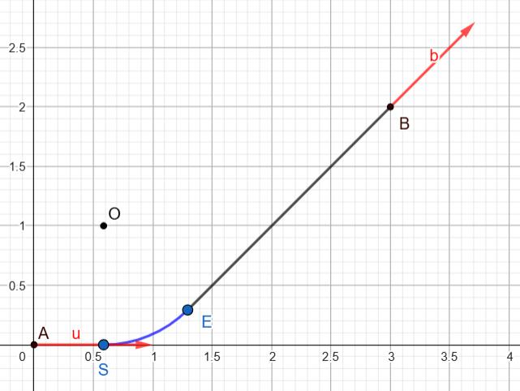
A Combined Curved Path combines curved portions with other types of paths.
For example:
$$\boxed{\text{Straight}→\text{Circular Arc}→\text{Parabolic Arc}→\text{Straight}}$$
Example
A road can consist of:
- a straight section,
- a circular turning section,
- another curved section,
- another straight section.
This is a combined path rather than a single elementary curve.

Mathematical Representation of a Curved Path
# Source: AI Source: Provided by: [Data Path: Persons Table -> ID Column: 1, Name_En Column: Motasem Essam] -> From: [ChatGPT] on [7/25/2026]
A general planar curved path can be represented parametrically as
$$\boxed{r\left(t\right)=\left\langle x , \left(t\right)y\left(t\right)\right\rangle }$$
for
$$t_{0}≤t≤t_{1}.$$
In three dimensions:
$$\boxed{r\left(t\right)=\left\langle x , \left(t\right) , y\left(t\right)z\left(t\right)\right\rangle }$$
The velocity direction is determined by
$$r^{'}\left(t\right).$$
The speed is
$$\boxed{v\left(t\right)=∥r^{'}\left(t\right)∥}$$
and, when the curve is sufficiently smooth, its curvature is
$$\boxed{κ\left(t\right)=\frac{∣x^{'}\left(t\right)y^{''}\left(t\right)-y^{'}\left(t\right)x^{''}\left(t\right)∣}{{\left(x^{'}{\left(t\right)}^{2}+y^{'}{\left(t\right)}^{2}\right)}^{3/2}}}$$
for a regular planar parametrization.

Curvature
# Source: AI Source: Provided by: [Data Path: Persons Table -> ID Column: 1, Name_En Column: Motasem Essam] -> From: [ChatGPT] on [7/25/2026]
One of the most important concepts distinguishing a curved path from a straight-line path is curvature.
For a straight line:
$$\boxed{κ=0}$$
For a circle of radius $r$:
$$\boxed{κ=\frac{1}{r}}$$
Therefore, a smaller circular radius means a sharper turn.
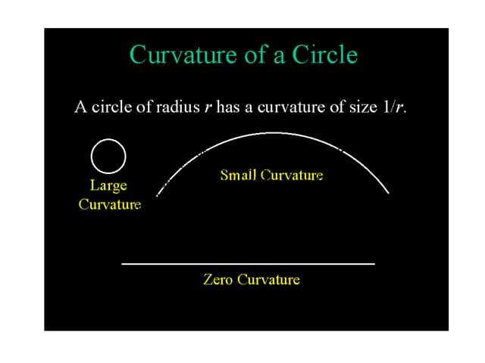
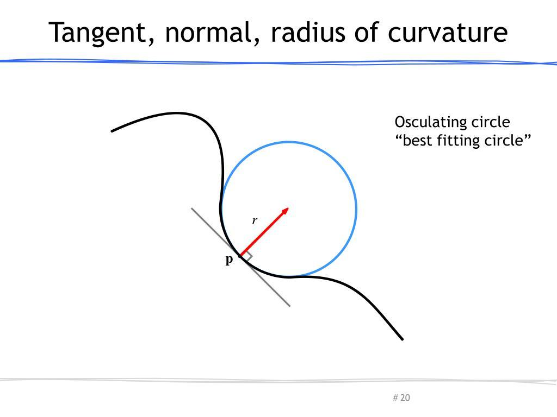
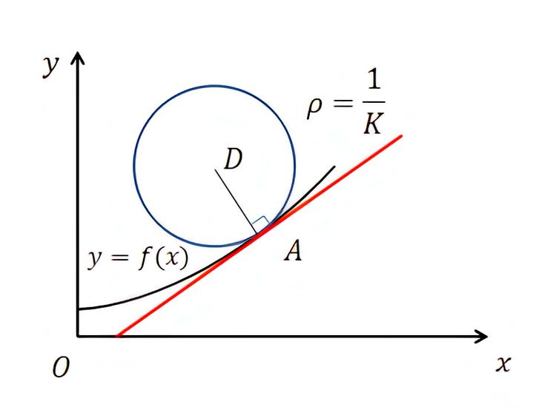
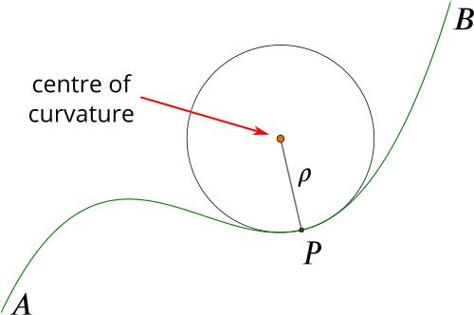
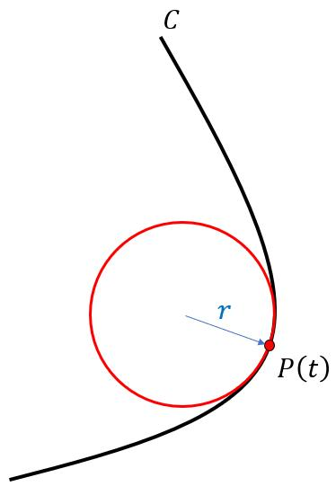

Length of a Curved Path
# Source: AI Source: Provided by: [Data Path: Persons Table -> ID Column: 1, Name_En Column: Motasem Essam] -> From: [ChatGPT] on [7/25/2026]
For a parametrically defined curve
$$x=x\left(t\right), y=y\left(t\right),$$
the arc length is
$$\boxed{L=\int_{t_{0}}^{t_{1}}{\sqrt{{\left(\frac{dx}{dt}\right)}^{2}+{\left(\frac{dy}{dt}\right)}^{2}}} dt}$$
For a circular arc:
$$\boxed{L=rθ}$$
where $θ$is in radians.
For a piecewise-curved path:
$$\boxed{L=L_{1}+L_{2}+⋯+L_{n}}$$

Curved Path vs Straight-Line Path
# Source: AI Source: Provided by: [Data Path: Persons Table -> ID Column: 1, Name_En Column: Motasem Essam] -> From: [ChatGPT] on [7/25/2026]
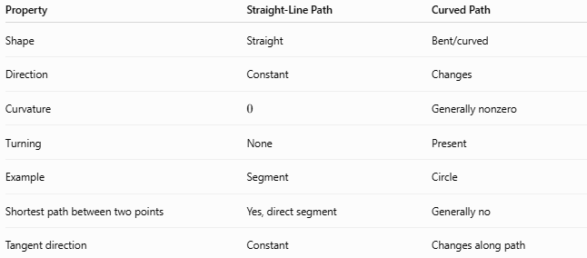
Property | Straight-Line Path | Curved Path
Shape | Straight | Bent/curved
Direction | Constant | Changes
Curvature | $$0$$ | Generally nonzero
Turning | None | Present
Example | Segment | Circle
Shortest path between two points | Yes, direct segment | Generally no
Tangent direction | Constant | Changes along path
Thus,
$$\boxed{\text{Straight-Line Path is a special zero-curvature case}}$$
while curved paths generally have
$$\boxed{κ≠0}$$
at points where they are genuinely curved.

Curved Path vs Circular Path
# Source: AI Source: Provided by: [Data Path: Persons Table -> ID Column: 1, Name_En Column: Motasem Essam] -> From: [ChatGPT] on [7/25/2026]
A Circular Path is only one specific type of curved path.
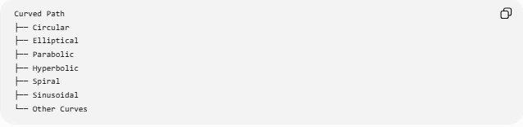
Curved Path
├── Circular
├── Elliptical
├── Parabolic
├── Hyperbolic
├── Spiral
├── Sinusoidal
└── Other Curves
Therefore:
$$\boxed{\text{Circular Path}⊂\text{Curved Path}}$$
A circular path has a constant radius from its center:
$$OP=r.$$
A general curved path does not necessarily have such a fixed center or constant radius.

Curved Path vs Piecewise-Curved Path
# Source: AI Source: Provided by: [Data Path: Persons Table -> ID Column: 1, Name_En Column: Motasem Essam] -> From: [ChatGPT] on [7/25/2026]
A Curved Path can be one continuous curve, while a Piecewise-Curved Path consists of several curve pieces.
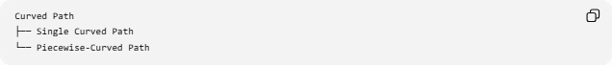
Curved Path
├── Single Curved Path
└── Piecewise-Curved Path
For example:
$$y=x^{2}$$
is a single parabolic path.
But
$$\text{Circle Arc}→\text{Parabolic Arc}→\text{Ellipse Arc}$$
is a piecewise-curved path.

Important Relationships
# Source: AI Source: Provided by: [Data Path: Persons Table -> ID Column: 1, Name_En Column: Motasem Essam] -> From: [ChatGPT] on [7/25/2026]
Curved Path and Locus
Many curved paths can be described as loci.
For example:
$$OP=r$$
produces a circle.
$$PF_{1}+PF_{2}=2a$$
produces an ellipse.
$$PF=d\left(P , l\right)$$
produces a parabola.
$$∣PF_{1}-PF_{2}∣=2a$$
produces a hyperbola.
Thus:
$$\boxed{\text{Geometric Condition}→\text{Locus}→\text{Curved Path}}$$

Classification Summary
# Source: AI Source: Provided by: [Data Path: Persons Table -> ID Column: 1, Name_En Column: Motasem Essam] -> From: [ChatGPT] on [7/25/2026]
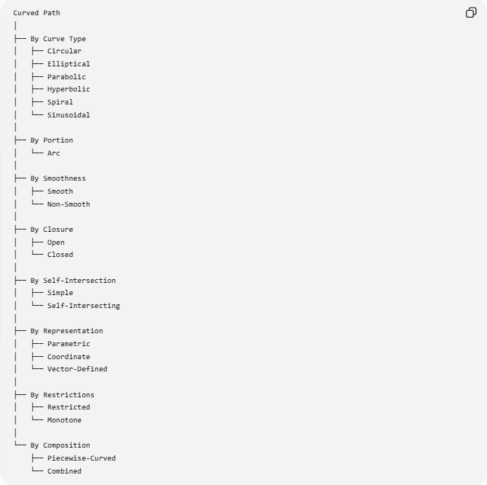
Curved Path
│
├── By Curve Type
│ ├── Circular
│ ├── Elliptical
│ ├── Parabolic
│ ├── Hyperbolic
│ ├── Spiral
│ └── Sinusoidal
│
├── By Portion
│ └── Arc
│
├── By Smoothness
│ ├── Smooth
│ └── Non-Smooth
│
├── By Closure
│ ├── Open
│ └── Closed
│
├── By Self-Intersection
│ ├── Simple
│ └── Self-Intersecting
│
├── By Representation
│ ├── Parametric
│ ├── Coordinate
│ └── Vector-Defined
│
├── By Restrictions
│ ├── Restricted
│ └── Monotone
│
└── By Composition
├── Piecewise-Curved
└── Combined

Key Formulas
# Source: AI Source: Provided by: [Data Path: Persons Table -> ID Column: 1, Name_En Column: Motasem Essam] -> From: [ChatGPT] on [7/25/2026]
General Parametric Curve
$$\boxed{r\left(t\right)=\left\langle x , \left(t\right)y\left(t\right)\right\rangle }$$
Circular Path
$$\boxed{{\left(x-h\right)}^{2}+{\left(y-k\right)}^{2}=r^{2}}$$
Elliptical Path
$$\boxed{\frac{{\left(x-h\right)}^{2}}{a^{2}}+\frac{{\left(y-k\right)}^{2}}{b^{2}}=1}$$
Parabolic Path
$$\boxed{y=a{\left(x-h\right)}^{2}+k}$$
Hyperbolic Path
$$\boxed{\frac{x^{2}}{a^{2}}-\frac{y^{2}}{b^{2}}=1}$$
Spiral
$$\boxed{r=f\left(θ\right)}$$
Sinusoidal Path
$$\boxed{y=Asin⁡\left(Bx+C\right)+D}$$
Arc Length
$$\boxed{L=\int_{t_{0}}^{t_{1}}{\sqrt{x^{'}{\left(t\right)}^{2}+y^{'}{\left(t\right)}^{2}}} dt}$$
Circular Arc Length
$$\boxed{s=rθ}$$
Curvature
$$\boxed{κ=\frac{∣x^{'}y^{''}-y^{'}x^{''}∣}{{\left(x^{'2}+y^{'2}\right)}^{3/2}}}$$

Key Points
# Source: AI Source: Provided by: [Data Path: Persons Table -> ID Column: 1, Name_En Column: Motasem Essam] -> From: [ChatGPT] on [7/25/2026]
- A Curved Path does not follow one straight line.
- Its direction generally changes along the path.
- Curvature is a fundamental measure of how strongly the path bends.
- Circular, elliptical, parabolic, and hyperbolic paths are important mathematical examples.
- A circular path is a special type of curved path.
- Curved paths can be open or closed.
- They can be simple or self-intersecting.
- They can be smooth or non-smooth.
- They can be represented using coordinates, parameters, or vectors.
- A restricted curved path is only a portion of a larger curve.
- A piecewise-curved path consists of several curved pieces.
- A combined path can contain curved and straight portions.
- Many curved paths can be interpreted as loci satisfying geometric conditions.
- The length of a general curved path is found using arc-length integration.

Conclusion
# Source: AI Source: Provided by: [Data Path: Persons Table -> ID Column: 1, Name_En Column: Motasem Essam] -> From: [ChatGPT] on [7/25/2026]
A Curved Path is a fundamental type of geometric path in which a point follows a non-straight trajectory. It includes many important forms such as circular, elliptical, parabolic, hyperbolic, spiral, and sinusoidal paths.
Curved paths can also be classified according to their smoothness, closure, self-intersection, mathematical representation, restrictions, and composition. Mathematically, they are commonly represented by coordinate equations, parametric equations, or vector functions.
The central idea is:
$$\boxed{\text{Curved Path}=\text{Non-Straight Geometric Trajectory}}$$
and, in contrast with a straight-line path,
$$\boxed{\text{Curved Path generally has changing direction and nonzero curvature.}}$$

